**UNITY UNIVERSITY**

**College of Engineering, Technology and Computational Sciences**

**Department of Computer Science and MIS**

**SHEGER NOTICE**

**Final Project Document**

**Submitted to department of computer science and MIS in partial fulfillment of the requirements for the degree of Bachelor Science in computer science**

**GROUP MEMBERS**

1. **GETINET FEKADU**
2. **MESAY MEKONEN**
3. **MICKAEL BELETE**
4. **MISGANA DANIEL**
5. **TINSAE ASRES**
6. **YITBAREK ASSEGED**

**Advisor:**

**Ato. Gulilat Yohannes**

**June, 2018**

**SHEGER NOTICE**

**Final Project Document**

**Submitted to department of computer science and MIS in partial fulfillment of the requirements for the degree of Bachelor Science in computer science**

**GROUP MEMBERS**

1. **GETINET FEKADU**
2. **MESSAY MEKONNEN**
3. **MICHAEL BELETE**
4. **MISGANA DANIEL**
5. **TINSAE ASRES**
6. **YITBAREK ASSEGED**

**Advisor:**

**Ato. Gulilat Yohannes Signature: _______________________**

**Examiner:**

**Name: _________________________ Signature: _______________________**

**Abstract**

Sheger Notice web based advertisement and notice display system.

Unity University, 2018

The main aim of this study is to solve the problems on the advertisement and notice industry. As the residence of Addis Ababa, one can notice that our advertisement and notice culture is absurd. First, when we start this project we started with the apparent problem, the cleanness of the city. We said the apparent problem because everywhere we go we see every walls and polls covered with advertisements and notices. But, we managed to find some other problems that must be addressed in the advertisement and notice industry. The first one is unregulated and unorganized advertisement and notice industry. Unregulated and unorganized industry is the way an advertisement and notice are disseminated through the city. Any person can look at a concrete wall nearby plastered with some kind of paper advertisement/notice. The second one is unimplemented laws, and regulation. Unimplemented laws and regulation is to imply that there are proclamations and regulations but the city administration lacks the capacity to implement them. If these laws are implemented, we may see a better advertisement/notice industry. The third is the cleanness of the city. A Paper-based advertisement/notice that is produced each day filling the city in every direction is one of the problem of the city sanitation. The option is not to eliminate but to limit or regulate the production of paper-based advert/notice by digitalizing the industry. The last is none vetted advertisement and notice. None vetted advertisement and notices that are unlawful, immoral, and culturally wrong contents are filling the city in four direction.

To solve these problems the project goes above and beyond, by implementing different techniques. The business rule makes the advertisers and the advertisement agent to think twice before sending any material. The business rule is one of the vetting process, which avoids immoral, unlawful, and insensitive materials. Analyses are done on the current and proposed system. We manage to interview the advertisers on the process of advertisement and notice from the conception to the end. Then, not only integrating it but also, making it interactive, engaging and entertaining. Data are collected. The data that are collected are mostly high definition pictures, videos and audios. The design aspects are done so that every visitor will be captivated, involved, and amused with the features through its stay on the site. We use every possible techniques to minimize the line of code without compromising the performance of the site. We make it easy to find any information provided that it is in the database, by creating categories for each subject matter. So if you advertise on our site your information can be accessed easily by millions of people.

**Acknowledgment**

First and for most we would like to thank our God almighty for helping us throughout our lives. We would also like to thank our advisor Ato Gulilat Yohannes, who gave us valuable professional guidance and technical assistance throughout the course of this project. Last but not list we like to thank our families for the nonstop support they have given us.

**List of abbreviations**

|  |  |
| --- | --- |
| CMT | Content management tools |
| BR | Business rule |
| BSC | Bachelor of science |
| CON | Constraints |
| CRC | Class responsibility collaborator |
| CSS | Cascading style sheet |
| ETB | Ethiopian birr |
| FPSN | Final project sheger notice |
| FPSNEUC | Final project sheger notice essential use case |
| HTML | Hypertext markup language |
| MIS | Management information system |
| PHP | PHP hypertext preprocessor |
| RMMM | Risk mitigation monitoring management |
| SMART | Specific measurable achievable realistic time bounded |
| SQL | Structured query language |
| UI | User interface |
| WBS | Work breakdown structure |

**List of tables**

**Table 1: work breakdown structure (WBS) 35**

**Table 2: Resource planning (Human resource) 36**

**Table 3: Resource planning (Materials/equipment) 36**

**Table 4: Financial planning (human resource) 37**

**Table 5: Financial planning (materials/equipment) 38**

**Table 6: FPSN01 40**

**Table 7: FPSN02 41**

**Table 8: FPSN03 42**

**Table 9: FPSN04 42**

**Table 10: FPSN05 43**

**Table 11: FPSN06 44**

**Table 12: FPSN07 45**

**Table 13: FPSN08 45**

**Table 14; FPSN09 45**

**Table 15: FPSN11 47**

**Table 16: FPSN12 48**

**Table 17: FPSNEUC-01 55**

**Table 18: FPSNEUC-02 57**

**Table 19: FPSNEUC-03 57**

**Table 20: Constraints 80**

**Table 21: FPSN-01 83**

**Table 22: FPSN-02 85**

**Table 23: FPSN-07 85**

**Table 24: FPSN-05 86**

**Table 25: FPSN-06 87**

**Table 26: FPSN-11 88**

**Table 27: FPSN-09 89**

**Table 28: FPSN-13 89**

**Table 29: FPSN-14 90**

**Table 30: FPSN-16 91**

**Table 31: FPSN-18 91**

**Table 32: FPSN-19 92**

**List of figures**

**Figure 1: Gantt chart 20**

**Figure 2: Essential use case diagram 54**

**Figure 3: Essential UI for home page 58**

**Figure 4: Essential UI for login 59**

**Figure 5: Essential UI for register 60**

**Figure 6: Essential UI for contact 61**

**Figure 7: Essential UI for about us 62**

**Figure 8: Essential UI for submit advert/notice 63**

**Figure 9: Essential UI for payment 64**

**Figure 10: Essential UI for advertisement 65**

**Figure 11: Essential UI for notice 66**

**Figure 12: UI flow diagram 67**

**Figure 13: System use case 82**

**Figure 14: Sequence diagram for post advert/notice 92**

**Figure 15: Sequence diagram for check advert/notice 93**

**Figure 16: Sequence diagram for update/delete advert/notice 94**

**Figure 17: Sequence diagram for generate report 95**

**Figure 18: Sequence diagram for contact with cutomers 96**

**Figure 19: Sequence diagram for make payment 97**

**Figure 20: Sequnce diagram for login 98**

**Figure 21: Sequnce diagram for submit advert/notice 99**

**Figure 22: Sequnce diagram for register 100**

**Figure 23: Sequnce diagram for send comment 101**

**Figure 24: Sequence diagram for search advert/notice 102**

**Figure 25: Activity diagram for send comment 103**

**Figure 26: Activity diagram for make payment 104**

**Figure 27: Activity diagram for register 105**

**Figure 28: Activity diagram for check advert/notice 106**

**Figure 29: Activity diagram for post advert/notice 107**

**Figure 30: Activity diagram for search advert/notice 108**

**Figure 31: Activity diagram for contact with customers 109**

**Figure 32: Activity diagram for update/delete advert/notice 110**

**Figure 33: Activity diagram for generate report 111**

**Figure 34: Activity diagram for submit advert/notice 112**

**Figure 35: Activity diagram for login and visit 113**

**Figure 36: sub system decomposition 118**

**Figure 37: Class diagram 120**

**Figure 38: Persistence model 121**

**Figure 39: Table to be normalized 122**

**Figure 40: 1NF 122**

**Figure 41: 2NF 123**

**Figure 42: 2NF 123**

**Figure 43: 3NF 123**

**Figure 44: 3NF 123**

**Figure 45: Home page UI 124**

**Figure 46: Login UI 125**

**Figure 47: Register UI 125**

**Figure 48: Contact UI 125**

**Figure 49: About us UI 126**

**Figure 50: Advert UI 126**

**Figure 51: Advert details UI 127**

**Figure 52: Video adverts UI 127**

**Figure 53: Advert video play UI 128**

**Figure 54: Notice UI 128**

**Figure 55: Notice details 129**

**Figure 56: Submit advert/notice UI 129**

**Figure 57: Network diagram 131**

**Figure 58: Deployment diagram 132**

**Definitions of terms used**

1. “**Public advertisement**” means message in the public interest disseminated by the mass media;
2. “**Personal advertisement**” means an advertisement advertised through the means of advertisement dissemination and it includes looking for missing person advertisement, condolence message, and other similar advertisement;
3. “**Advertising activity**” means an activity that includes production and dissemination of advertisements, promotional services and other related activities;
4. “**Advertising agent**” means a person who undertakes advertising activity;
5. “**Advertisement disseminator**” means a person who disseminates advertisements through the use of means of advertisement dissemination by providing air time, column coverage or other related services;
6. “**Advertiser**” means a person whose advertisement is advertised through the means of advertisement dissemination;
7. “**Outdoor advertisement**” means any advertisement:
8. Disseminated by using billboard, electronic screen or moving picture;
9. Written or affixed to a building or any structure or transport vehicle;
10. Disseminated by using banner, poster, sticker, brochure, leaflets or flier;
11. Disseminated through audio cassette, loud speaker; or
12. Disseminated through any other related means of dissemination.

**Table of Contents**

**CHAPTER ONE** 12

**INTRODUCTION** 12

**1.** **BACKGROUND** 13

**2.** **Statement of the problem** 14

3. **Objective of the project** 15

**3.1 General Objective of the project** 15

**3.2 Specific Objectives of the project** 15

4. **Scope of the Project** 16

**Limitations of the project** 17

**5.** **Tools and Methodology** 17

**5.1 Data Collection Methodology** 17

**5.2 Development Tools** 18

**5.3 System Development Methodology** 18

6. **Beneficiaries of the project** 19

7. **Schedule** 20

**CHAPTER TWO** 21

**PROJECT MANAGMENT** 21

**1.** **Introduction** 21

**2.** **Project Planning (WBS)** 22

**3.** **Resource planning** 35

**3.1 Human resource** 35

**3.2 Materials/Equipment** 36

**4.** **Financial planning** 37

**4.1 Human resource** 37

**4.2 Materials/Equipment** 37

**5.** **Team organization** 38

**6.** **Process modeling** 39

**7.** **Risk MMM plan** 39

**7.1 Risk item sheet** 39

**7.2** **RMMM plan** 40

**CHAPTER THREE** 49

**SYSTEM ANALYSIS** 49

**1. Introduction** 49

**3. Proposed system overview** 52

**3.1 Functional requirements** 52

**3.2 Non-functional requirements** 53

**4.** **System Models** 54

**4.1 Essential use case modeling** 54

**4.2** **Essential UI prototype and UI flow diagram** 58

**4.3CRC Modeling** 68

**4.4** **Supplementary Specification** 70

**5. Analysis System Models** 82

**5.1 System use case modeling** 82

**5.2 Sequence diagram** 92

**CHAPTER FOUR** 114

**SYSTEM DESIGN** 114

**1.** **Introduction** 114

**2.** **Design Goals** 114

**3.** **Design tradeoff** 117

**5.** **Class diagram** 119

**6. Persistent Model** 121

**6.2 Normalization** 122

**7.** **UI design** 123

**8.** **Network Diagram** 130

**9. Deployment diagram** 132

**CHAPTER FIVE** 133

**IMPLEMENTATION** 133

**1.** **Introduction** 133

**2.** **Sample code** 134

**CHAPTER SIX** 152

**CONCLUSION AND RECCOMENDATION** 152

**1.** **Conclusions** 152

**2.** **Recommendations** 154

**Bibliography** 156

# **CHAPTER ONE**

# **INTRODUCTION**

The world is changing rapidly. Especially due to the fast economic growth of the country, Ethiopian cities are going through dramatic change. One of this change is the way people get information in their day-to-day life. Now a days, we have many choices where to look for information. TV, radios, internet, printed advertisement, notice board, and the recent phenomenon are social Medias. The main focus of this project, the capital city Addis Ababa is bombarded with useful and useless information in every direction. Have your eyes rest for a second without seeing an advertisement, or notices? If you noticed, the city street cleaner’s swipes the street in the morning; most of the litters are broachers and fliers? Have you notice the polls, the railways wall, private and public walls, walls of buildings, and traffic stands, of Addis Ababa. If you notice throughout the city, every walls, polls, buildings and railroad walls are covered by useful and useless “advertisement” and “notices”. Banners, posters, stickers, broachers, leaflets, and fliers jam-packed the city in every direction. Do not take us wrong, advertisements plays a significant role in the nation’s economic, social and political development, by influencing the activities of the public in market exchange or service providing, also advertisement makes a significant contribution in establishing healthy market competition in the economic system of the country. So as notice; job vacancies, bids, trademark introduction, auctions, and many other opportunities are created through notice.

As much as it produced many opportunities, there are advertisements and notices that are not well vetted, misleading, and wrong. Bothe advertisement and notice, if not regulated, may harm the rights and interest of the people and the image of the country. You should not go far to notice this. Addis Ababa’s walls packed with advertisement/notice staring from “ቦርጭዎን ማጥፋት ይፈልጋሉ?” to”የትዳር ጓደኛ በአጭር ጊዜ“ these are unethical, out of the norms and cultures of Ethiopians. A close examination leads you to conclude it is an empty promise only to generate money from desperate and vulnerable people. According to article 9 sub-article 1 of advertisement proclamation under the title advertisements required special certificate states that ‘*Prior certification by the appropriate body shall be required in order to promote products or services that have to meet mandatory standard requirements.*’(The Advertisement Proclamation No.759/2012) Nevertheless, no one is regulating it at the moment. Advertisements should be truthful, reliable, well-vetted, right, informative, entertaining, respect the culture and values of the people, respect the law of the land, and in-line with public moral and safety. The aims and goals of this project are to make the industry truthful, reliable, well-vetted information, right, informative, entertaining, respect the culture and values of the people, respect the law of the land, and finally in-line with public moral and safety. We hope this project work will be the stepping-stone for the web-based digitalization of the industry that the format will be text, picture, audio, and video.

1. **BACKGROUND**

Before going further, let us see what advertisement and notice is. The Advertisement Proclamation, No.759/2012 article (1) of Ethiopia, defines advertisement as *‘means a commercial advertisement which is disseminated through the means of advertisement dissemination to promote sales of goods or services or to publicize name, logo, trademark or objectives, and includes public and private advertisements.’* (The Advertisement Proclamation No.759/2012). Oxford advanced learner’s dictionary define advertisement as, *‘a notice, picture, or film telling people about a product, job, or service.’* In addition,it is *‘an example of something that shows its good qualities’* (Oxford advanced learner’s dictionary 7th ed. 2010). As stated, advertisements aim to convince consumers to purchase a specific product or brand. It tries to convince consumers to buy goods and services here rather than from somewhere else by employing persuasive language to cast the business, product or service in the most favorable light and make it more appealing. Although advertisements cannot intentionally deceive by providing false information about a product, they receive considerable freedom in how they go about making a product or service appealing. A product advertisement might focus on positive rather than draw attention to its negative content.

Notice on the other hand, is ‘*a warning or information of something and a written or printed announcement*.’ (Merriam Webster dictionary 2009) or *‘information or a warning giving in advance of something is going to happen’* (Oxford advanced learner’s dictionary 7th ed., 2010). Notices typically appear as blocks of text in print or online. The text serves to convey information about government actions, business activities and social issues that has impact on the lives of citizens. In general, notice is a formal statement in writing or announcement that is paper based or online, which gives information or warning something is going to happen. Notice should be exact, precise, simple, clear and comprehensive so that the reader can understand it easily. It should be noted that, both advertising and notice are for public consumption.

As we see from the above explanations, both advertisement and notice has their own distinction and similarities. Advertisement should not be told as a notice and notice should not told as an advertisement. The other problem is the way it is disseminated. Most of the advert and notice are produced as a printed material, which should be dispersed to reach on the hand of the public or posted on the wall of public and private property. The other problem is keeping the advisement industry in the context of Ethiopian values and norms. Not only that making it in line with the law of the land. The opportunity presented here is in federal level Ethiopia has advertisement proclamation stating any advertisement should follow this law. The down side is the Addis Ababa administration has no laws regulating how this industry can be managed. The federal proclamation prohibits using billboard in public places except in private property. The problem is no one is implementing it. The gap in the law and in practice gives the image that we see in Addis Ababa now.

As a group, we believe the advertisement/notice industry is one part of the change we aspire for Addis Ababa. However, we always wonder when and how it can be structured and regulated. On this regard, Addis Ababa is not matching her name. If we can reduce all these it would be best, but it takes time and effort. For sure it can be done. Until this change happen, we would like to devise a method for the city. We believe the city should have a web based centralized and digitalized advertisement and notice system used as a notice e-board where people should get what they need when they need it at the right time. The proposed system is a supplementary information billboard and notice board with broad category of choices that visitors view and filter information that they only needed. Advertisements, jobs, markets, books, newspaper, magazines, notices, entertainments, conferences, exhibitions, and bathers, information that is happening or going to happen will be viewed by visitors. The steps will be easy the information will be detail. This helps them to get specific information, any time anywhere. And we call it **Sheger Notice**.

1. **Statement of the problem**

A project may be lunched to solve a problem or combination of problems. As stated on the introduction and background, there are four reasons way we think of this project. The first one is unregulated and unorganized industry, the second one is unimplemented laws and regulation, the third is the cleanness of the city. The last is none vetted advertisement and notice. Unregulated and unorganized industry is the way an advertisement and notice are disseminated through the city. Any person can look at a concrete wall nearby plastered with some kind of paper advertisement/notice. Unimplemented laws and regulation is to imply that there are proclamations and regulations but the city administration lacks the capacity to implement them. If these laws are implemented, we may see a better advertisement/notice industry. The other point is the cleanness of Addis Ababa. A Paper-based advertisement/notice that is produced each day filling the city in every direction is one of the cause of the city’s problem on sanitation. The option is not to eliminate but to limit or regulate the production of paper-based system by digitalizing the industry. Lastly, none vetted advertisement and notices that are unlawful, immoral, and culturally wrong contents are filling the city in four direction. If we do not want to expose the public to such advertisements/notices, we must devise a channel to inspect such postings lawfully.

Therefore, this project is an effort in solving these problems associated with the unregulated and unorganized industry, the unimplemented laws and regulation, the cleanness of the city, and none vetted advertisement/notice. Those plastered print advertisements and notices around the town in a manner that is changing the city’s image badly. The Efforts may be geared towards the minimization, if not the total elimination. By doing this project the city, the advertising agent, advertiser and the visitor of the site will be beneficiary.

1. **Objective of the project**

### **3.1 General Objective of the project**

* Develop web-based advertisement and notice e-board[1].

### **3.2 Specific Objectives of the project**

* Contribute to the advertisement and notice industry by digitalizing.
* To make standardized advertisement and notice.
* Minimizing advertisement cost and time.
* Conveying reliable, vetted, morally and culturally acceptable information.
* Making advertisements and notices easily available 24/7.
* Contributing to the transformation of the city.
* Creating centralized information system.
* Contributing to paper free advertisement
* Increasing the accessibility of advertisements and notices
* Decreasing advertisers concerns regarding advertising policies and laws.
* Design easy, user-friendly system.
* To increase the accessibility of advertisements and notices.

1. **Scope of the Project**

The proposed system has two different parts, one for theadvertiserand the other forthe end user/site visitor. The scopes of the project are:

* **The company/advertiser: -**
* An advertiser [2]must register and provide verification on the product and/or service.
* Send advertisement and/or notice to the site manager.
* The advert or notice must fulfill the rules and regulations set by the site managers.
* The site manager may accept it, if satisfied; the advertisement or notice will be posted on the site.
* The advertiser will be informed that his advert or notice is accepted or rejected. In addition, that he can view what has been posted.
* **The end user/ site visitor: -**
* They can visit the site and view what has been posted by the site user.
* Comment on the advertisements/ notices forum by registering.

**Limitations of the project**

* The site displays advertisements and notices. User cannot buy or sell.
* The users/visitors of the site do not need to register to view contents.
* The system only works where there is internet access.
* Advertiser cannot directly post advertisement/notice.

1. **Tools and Methodology**

This part deals about the method of data collection, system development, and development tools.

### **5.1 Data Collection Methodology**

* **Document (**supplementary method)

Collecting information from different government and privet institution, references books, other projects, web sites, and the internet.

* **Proclamations** **and regulations**

By referring proclamations and regulations of advertisement/notice on the Negarit gazette and city administration.

* **Brainstorming**

By discussing and analyzing the problems with project team.

* **Interview**

To gather information, interview will be conducted with different advertisers, print houses and individuals living in the city.

* **Observation**

To assess the current system of print advertisement and find the gap between print advertisement and online advertisement. Additionally,

### **5.2 Development Tools**

**5.2.1 Front End**

* HTML
* CSS
* Jscript

**5.2.2 Back End**

* MySQL
* PHP
* Apache

**5.2.3 Documentation**

* Microsoft office word 2013.
* Microsoft office PowerPoint 2013
* Microsoft office Visio 2013
* Microsoft office paint.

### **5.3 System Development Methodology**

According to the book Systems Analysis and Design with UML Version 2.0 An Object-Oriented Approach 2nd Edition by Alan Dennis, Barbara Haley Wixom, David Tegarden, there are six requirement to select the appropriate system development methodology. These are, Clarity of User Requirements, Familiarity with Technology, System Complexity, System Reliability, Short Time Schedules and Schedule Visibility. When we choose agile system development methodology, we share the author’s viewpoints. *‘These Agile Methodologies share three key principles: (1) a focus on adaptive rather than predictive methodologies, (2) a focus on people rather than roles, and (3) a self-adaptive process.’* Even though we know what type of web site it turn out to be, from this point we cannot determine what the end product will be this is the behavior of any software product, so our product- web based advertising/notice e-board system will be incremental. We will make it progressively adaptive. We as a group believe each group members contribute to this project unique quality and talent, so rather than giving out rolls, we let each group member to bring its own uniqueness and talent to the best quality of the project work. Finally, Agile Methodologies promote a self-adaptive software development process. As the methodologies are applied, they should adapt different technology. No single uniform methodology effectively fits all developers on all projects at all times. As we stated, clarity of user requirements, familiarity with technology, system complexity, system reliability, short time schedules and schedule visibility are the main criteria to select system development methodology. User requirement will be negotiated with the developers and users, in accordance to the law and the intention of the developers what the system wanted to achieve. Since all the developers are familiar with most of the technology, we will not to resort to new technology that are very time consuming and take longer time to learn but, if it is necessary we will learn anything that full fill this project. We believe the system is not that much complex for the developers. As much as possible we will work for system reliability to be the core of our project. Short time schedule fits very perfectly. Finally, schedule visibility, schedule in this project are visible but it should not be a burden to the quality of the project, if necessary we go back and forth whenever change is needed.

1. **Beneficiaries of the project**

The beneficiaries of the project are listed below.

* Addis Ababa city

The capital city of Ethiopia is one of the primary beneficiaries of the project. The project makes the city more clean and neat in respect to the unregulated postings of paper adverts.

* Developers of the project

We the developers have benefited a lot from this project like upgrading our know how on coding with different programming languages e.g. HTML, CSS, PHP and JavaScript also with the preparation of the documentation of the project.

* Advertisers

This project will benefit the advertisers with respect to minimizing the cost of money for individuals to plaster the advert/notice and the overall cost of advertisement since our project costs less than most ad. Companies.

* Users/ visitors

Users are the second most beneficiaries of this project. The project will help the users/visitors to find the advert/notice they want in one place at any time and at any place.

1. **Schedule**

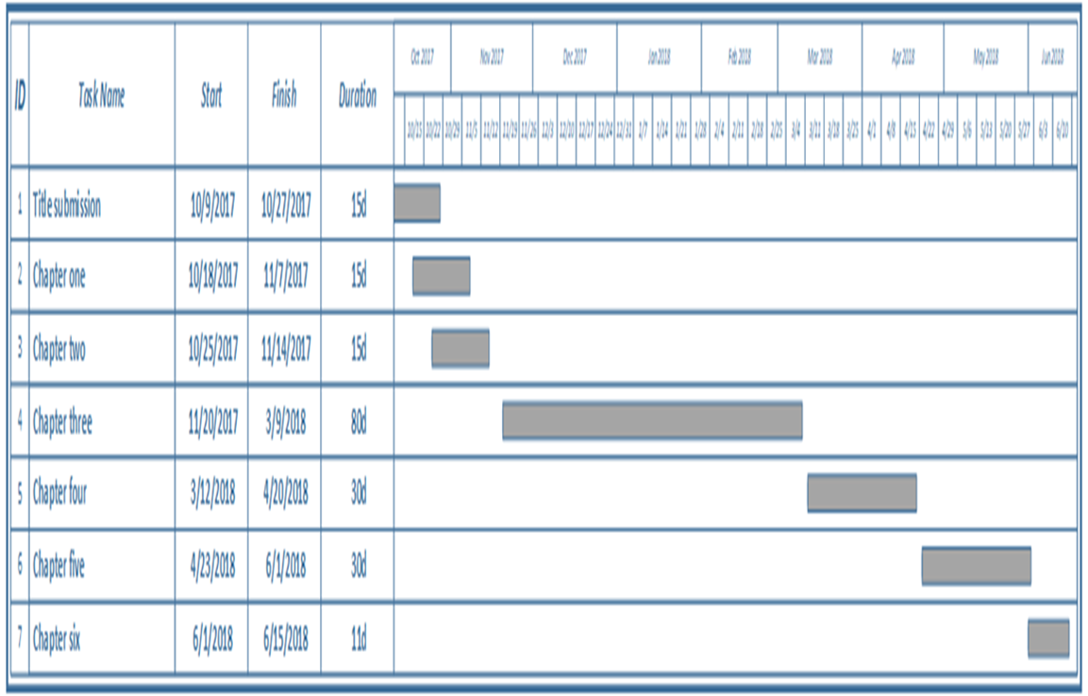

**Figure 1: Gantt chart**

# **CHAPTER TWO**

# **PROJECT MANAGMENT**

1. **Introduction**

Project management is one of the tasks that are performed throughout the lifecycle of the project. It ‘*manage the software development project, including planning, staffing, and monitoring the project, as well as managing the risks.*’ (Object-oriented analysis and design with applications / Grady Booch... [Etal.].—3rd ed., 2007). Most books agree that project is a planned undertaking of related activities, having a beginning and an end, to reach an objective. Therefore, formally, Project management is the process of planning and controlling the development of a system within a specified period at a minimum cost with the right functionality. When project became larger, there is a greater need for project management. In a nutshell, the focus of project management is to ensure that system development projects meet the customer’s expectations, delivered within budget, and in time. Since, project is temporary; project management is a controlled process of initiating, planning, executing, and closing down of a project. As the saying goes, to be prepared is half the victory.

Some of the advantages of project management are listed below:

**Less anxiety**

* Both in the side of the advertiser and the developers side it lessens the anxiety, since most of the outcomes are well documented and known.

**Better efficiency in delivering service**

* If every requirements and deliverables are stated clearly, it is a road map to project completion in turn lead to better efficiency in time, budget, and delivering service. It also helps develop a full understanding of the project goals, objectives and benefits before committing significant resources.

**Enhance customer satisfaction**

* If there is better efficiency in delivering service, advertiser’s satisfaction will be granted.

**Smarter decision**

* Using project management helps us to deploy every possible technique of scientific management methodology. These in turn produce decisions based on scientific backing, which will be smart and SMART.

**Increase risk assessment**

* If every strategy is in palace and well implemented, potential risk will jump out.

**Increase quality**

* In general, if we implement all of the above, it would be an educated guess expects greater quality.

1. **Project Planning (WBS)**

|  |  |  |  |  |  |
| --- | --- | --- | --- | --- | --- |
| **Task No.** | **Task Name** | **Duration**  **(days)** | **Dependency** | **Status** | **Deliverable** |
| 1 | **Introduction** |  |  | **Completed** | **Chapter one documentation** |
| 1A | **Introduction**   * Brain storming * Document preparation | 1 | **1A** | **“** |
| 1B | **Statement of the problem**   * Brain storming * Document/data collection * Document/data analysis * Document preparation | 1 | **1A** | complete |
| 1C | **Objective**   * Brain storming * Document/data analysis * Document preparation | 1 | **1B** | “ |
| 1D | **Scope**   * Brain storming * Document/data analysis * Document preparation | 2 | **1C** | “ |
| 1E | **Tools and Methodology**   * Brain storming * Document preparation | 1 | **1D** | “ |
| 1E-1 | **Data Collection Methodology**   * Brain storming * Document/data analysis * Document preparation | 2 | **1E** | “ |
| 1E-2 | **System Development methodology**   * Brain storming * Document/data analysis * Document preparation | 2 | **1E-1** | “ |
| 1E-3 | **Development tools**   * Brain storming * Document preparation | 1 | **1E-2** | “ |
| 1E-3-1 | **Front End**   * Brain storming * Document preparation | 1 | **1E-3** | “ |
| 1E-3-2 | **Back End**   * Brain storming * Document preparation | 1 | **1E-3-1** | “ |
| 1F | **Beneficiaries**   * Brain storming * Document preparation | 1 | 1B,1C,1D | “ |
| 1G | **Schedule**   * Group discussion * Document preparation | 1 | **-** | “ |
| 1H | **Review** | 1 | **1A,1B,1C,1D,1E** |  |
| **2** | **Project Management** |  |  | completed | **Chapter two documentation** |
| 2A | **Introduction**   * Groupdiscussion * Document preparation | **1** | **-** | **“** |
| 2B | **Project Planning(WBS)**   * Brain storming * Group discussion * Document preparation | **2** | **1G** | **“** |
| 2C | **Resource Planning**   * Group discussion * Document preparation | **1** | **1G,2B** | **“** |
| 2C-1 | **Head count**   * Group discussion * Document preparation | **1** | **1G,2B,2C** | **“** |
| 2C-2 | **Material and Equipment**   * Document preparation | **1** | **1G,2B,2C,2C-1** | **“** |
| 2D | **Financial Planning**   * Analysis * Group discussion * Document preparation | **1** | **1G,2B,2C** | **“** |
| 2D-1 | **Head count**   * Group discussion * Document preparation | **1** | **1G,2B,2C** | **“** |
| 2D-2 | **Material and Equipment**   * Document preparation | **1** | **1G,2B,2C** | **“** |
| 2E | **Team Organization**   * Group discussion * Document preparation | **1** | **2B,1D,1G** | **“** |
| 2F | **Process Modeling**   * Analysis * Group discussion * Document preparation | **1** | **2E** | **“** |
| 2G | **Risk Item Sheet**   * Analysis * Group discussion * Document preparation | **4** | 1C,1D,2B | **“** |
| 2G-1 | **Risk MMM Plan**   * Analysis * Group discussion * Document preparation | **1** | **2G,** | **“** |
| 2H | **Review** | **1** | 2A,2B,2C,2D,2E,2F,2G | **“** |
| 3 | **System analysis** |  |  | **“** | **Chapter three Documentation** |
| 3A | **Introduction**   * Analysis * Group discussion * Document preparation | **2** | **-** | **“** |
| 3B | **Current system overview**   * Analysis * Group discussion * Document preparation | **2** | **3A** | **“** |
| 3C | **Proposed system overview**   * Analysis * Group discussion * Document preparation | **1** | **3B** | **“** |
| 3C-1 | **Functional requirements**   * Analysis * Group discussion * Document preparation | **3** | **3C** | **“** |
| 3C-2 | **Non-functional requirements**   * Analysis * Group discussion * Document preparation | **2** | **3C** | **“** |
| 3D | **System models** |  |  | **“** |
| 3D-1 | **Essential use case modeling**   * Analysis * Group discussion * Document preparation | **2** | **3A** | **“** |
| 3D-1-1 | **Use case diagram**   * Analysis * Group discussion * Document preparation | **3** | **3C,3C-1** | **“** |
| 3D-1-2 | **Use case documentation**   * Analysis * Group discussion * Document preparation | **2** | **3C,3C-1,3D-1** | **“** |
| 3D-2 | **Essential UI prototype and flow diagram**   * Analysis * Group discussion * Document preparation | **3** | **3C** | **“** |
| 3D-3 | **CRC diagram**   * Analysis * Group discussion * Document preparation | **2** | **3C** | **“** |
| 3D-4 | **Supplementary specification**   * Analysis * Group discussion * Document preparation | **2** | **3C** | **“** |
| 3D-4-1 | **Business rule**   * Analysis * Group discussion * Document preparation | **3** | **3C** | **“** |
| 3D-4-2 | **Constraints**   * Analysis * Group discussion * Document preparation | **2** | **3C** | **“** |
| 3D-4-3 | **Change case**   * Analysis * Group discussion * Document preparation | **2** | **3C,3C-1,3C-2** | **“** |
| 3E | **Analysis System models** |  |  | **“** |
| 3E-1 | **System use case models**   * Analysis * Group discussion * Document preparation | **2** | **3C,3C-1,3C-2** | **“** |
| 3E-1-1 | **System use case diagram**   * Analysis * Group discussion * Document preparation | **3** | **3C,3C-1,3C-2,3E** | **“** |
| 3E-1-2 | **System use case documentation**   * Analysis * Group discussion * Document preparation | **1** | **3C,3C-1,3C-2,3E,3E-1-1** | **“** |
| 3E-2 | **Sequence diagram**   * Analysis * Group discussion * Document preparation | **2** | **3E-1-2** | **“** |
| 3E-3 | **Activity diagram**   * Analysis * Group discussion * Document preparation | **3** | **3E-1-2** | **“** |
| 4 | **System design** |  |  | **“** | **Chapter four Documentation** |
| 4A | **Introduction**   * Analysis * Group discussion * Document preparation | **1** | **3** | **“** |
| 4B | **Design goals**   * Brainstorm * Analysis * Group discussion * Document preparation | **1** | **3** | **“** |
| 4C | **Design trade off**   * Analysis * Group discussion * Document preparation | **1** | **3** | **“** |
| 4D | **System decomposition**   * Brainstorm * Analysis * Group discussion * Document preparation | **3** | **3** | **“** |
| 4E | **Class diagram**   * Analysis * Group discussion * Document preparation | **2** | **3C,3C-1** | **“** |
| 4F | **Persistent model** |  |  | **“** |
| 4F-1 | **Mapping class diagram to relation**   * Brainstorm * Analysis * Group discussion * Document preparation | **2** | **3C,3C-1** | **“** |
| 4F-2 | **Normalization**   * Analysis * Group discussion * Document preparation | **2** | **3C,3C-1** | **“** |
| 4G | **User interface diagram**   * Analysis * Group discussion * Document preparation | **2** | **3C,3C-1** | **“** |
| 4H | **Network diagram**   * Group discussion * Document preparation | **1** | **3C** | **“** |
| 4I | **deployment diagram**   * Analysis * Group discussion * Document preparation | **1** | **3C** | **“** |
| 5 | **Implementation** |  |  | **“** | **Website and chapter five documentation** |
| 5A | **Implementation**   * Brainstorm * Document preparation | **23** | **3C,3C-1** | **“** |
| 5B | **Sample code**   * Document preparation | **1** | **5A** | **“** |
| 6 | **Conclusion and recommendation** |  |  | **“** | **Chapter six Documentation** |
| 6A | **Conclusion**   * Group discussion * Document preparation c | **2** | **1,2,3,4,5** | **“** |
| 6B | **Recommendation**   * Group discussion * Document preparation | **2** | **1,2,3,4,5** | **“** |

**Table 1: work breakdown structure (WBS)**

1. **Resource planning**

### **3.1 Human resource**

|  |  |  |  |
| --- | --- | --- | --- |
| **Human Resource type** | **Head Count** | **Qualification** | **Responsibility** |
| System Analyst | 1 | * BSC degree in computer science with business background. * Must have knowledge of the relevant system Analysis profession. | * Identifying the objectives of the project. * Planning the system. * Gather different requirements * Understand the problem carefully. * Identify alternative solutions. * Determine the functionality of the solutions. * Design the scope of the project. |
| Database Developer | 1 | * BSC degree in computer Science. * Specialize in database developing & database Administrator. | * Develop & maintain databases across the organization * Ensure all database systems meet business & performance requirement |
| Interface Designer | 2 | * B.S.C degree in computer science * Good Knowledge about HTML,CSS,JAVASCRIPT | * Design attractive interface * Design easy to use or user friendly interface |
| Programmer | 2 | * B.S.C degree in computer science * Good knowledge about PHP, SQL, HTML, CSS * Good knowledge about installing, configuring and maintaining PHP, Apache and MySQL packages | * Writing codes * Fix errors * Prepare documentation of code for other programmers |
| Project Manager | 1 | * B.S.C degree in MIS (Management Information System). * Experienced in good communication and leadership. | * Manage the overall project * Ensuring schedule and requirements are met. |

**Table 2: Resource planning (Human resource)**

### **3.2 Materials/Equipment**

|  |  |  |  |  |
| --- | --- | --- | --- | --- |
| **No.** | **Item** | **Quantity** | **Specification** | **Justification** |
| 1 | Laptop computers | 4 | * Core i5 Processor. * 1 TB Hard Disk * 8GB RAM * 2GB Graphics Card * 2.2 GHZ speed CPU. | * Interface designing * For programming * For database developing * For system analyst. * Used as server. |
| 2 | Printers | 1 | HP LaserJet printer 1018 | Every printing needs of the project. |
| 3 | External hard disk | 2 | Seagate 1TB 3.0 serial cable | Backup, transporting data from one medium to another and Storage. |
| 4 | Software |  | * Microsoft word 2016 * Microsoft presentation 2016 * Xampp server 5.0 |  |
| 5 | Stationary |  | * Pen * Pencil * A4 paper * Stapler * Sticky note * Marker | For all the stationary needs of the project. |
| 6 | Internet |  |  | * For reference * For gathering information * For contacting each other * For expert advice -forums |

**Table 3: Resource planning (Materials/equipment)**

1. **Financial planning**

### **4.1 Human resource**

|  |  |  |  |
| --- | --- | --- | --- |
| **Employees** | **Head count** | **Salary(ETB)** | **Total (ETB)** |
| Interface designer | 2 | 3,500 | 7,000 |
| Programmer | 2 | 4,000 | 8,000 |
| Database administrator | 1 | 3,000 | 6,000 |
| Editor | 1 | 3,500 | 6,500 |
| Project Manager | 1 | 6,500 | 6,000 |
| **Total** | **7** | **20,000** | **33,500** |

**Table 4: Financial planning (human resource)**

### **4.2 Materials/Equipment**

|  |  |  |  |
| --- | --- | --- | --- |
| **Items** | **Quantity** | **Unit price(ETB)** | **Total price (ETB)** |
| Laptop Computer | 6 | 15,700 | 47,100 |
| CD-ROM | 1 | 12 | 12 |
| External Hard Disk | 1 | 2,500 | 2,500 |
| Pen | 1 dozen | 72 | 72 |
| Pencil | 3 pic | 6 | 18 |
| Paper | 1 pack | 115 | 115 |
| Sticky note | 1 | 12 | 12 |
| Flash Disk | 6 | 180 | 1,080 |
| Internet | 23 GB | 165 | 3,795 |
| **Total** | | | 54,704 |

**Table 5: Financial planning (materials/equipment)**

1. **Team organization**

Team organization means the way the project development team communicates with each other to exchange or share information. This method of communication can be categorized into three. The first one is centralized, which team member’s communication and information sharing is emanated from a centralized authority. This type of communication is important if team members have less knowledge about the task that is performed. The second one is decentralized team organization, in this form of team organization; information flows form any direction as long as it is important for the project. The last one mixed control which the mixtures of both. Among the three team organization types we selected the decentralized team organization to develop our project for the following reasons:

* All have equal responsibilities on the project
* To avoid a hierarchy which will somehow hinder free communication among all development team
* To create a conducive environment for creativity

1. **Process modeling**

A process model provides a specific roadmap for project. It defines as *“…the flow of all activities, actions and tasks, the degree of iteration, the work products, and the organization of the work that must be done.” (Roger .s & Rruce R. 2015).* From the different types of process models, we have chosen incremental process models based on the following reasons:

* It combines linear and parallel process flow
* The first increment is often core product
* It generate a working system quickly and early
* It is more flexible and less costly to change scope and requirements
* It is easier to test and debug during a smaller iteration
* It is easier to manage risk because risky pieces are identified and handled during its iteration

1. **Risk MMM plan**

### **7.1 Risk item sheet**

* FPSN01.Change in schedule
* FPSN02.Requirement change
* FPSN03.Cost overrun
* FPSN04.Time Shortage
* FPSN05.Computer(Server) crash
* FPSN06.End user/advertiser resist system
* FPSN07.Difficulty working with each other among development team
* FPSN08.Budget Shortage
* FPSN09.Not following the advisors advice
* FPSN10.Not meeting customer expectation
* FPSN11.Poor requirement Analysis
* FPSN12.Lack of developer experience
  1. **RMMM plan**

|  |  |  |  |
| --- | --- | --- | --- |
| **Risk Information Sheet for Change in Schedule** | | | |
| **Risk ID:** FPSN01 | **Date:** | **Probability:** 30% | **Impact:** Marginal |
| **Description:**  Since all phases are interrelated, schedule change may occur. | | | |
| **Refinement/context:**  Sub-condition 1: Schedule change may occur when waiting for approval of the phase.  Sub-condition 2: Team member may miss scheduled meeting.  Sub-condition 3: Estimated time for project tasks may be shorter. | | | |
| **Mitigation:**   1. Group members should not wait for project phase approval. 2. Group members should be strictly disciplined for schedule meetings. 3. Plan wisely each task. Leave a room for schedule change. | | | |
| **Monitoring:**   1. Project phase should be listed before the project begin so that progress can be tracked. 2. All group members should be knowledgeable about all project phase so, anyone can do anyone’s task. 3. Revise time schedule before, during and after project task. | | | |
| **Management/contingency plan:**   1. Re-adjust time project schedule to fit the left over task. 2. Project members should know the importance of this project, work beyond schedule time until project schedule in line with schedule. 3. Calculate the gap in project schedule and work until the gap is eliminated. | | | |
| **Current status:** | | | |
| **Originator:** Misgana Daniel | | **Assigned:** Michael Belete | |

**Table 6: FPSN01**

|  |  |  |  |
| --- | --- | --- | --- |
| **Risk information sheet for last time requirement change** | | | |
| **Risk ID:**FPSN02 | **Date:** | **Probability:** 30% | **Status:** Critical |
| **Description:** Since this project idea is new, and the team is inexperienced, requirement may change time to time. | | | |
| **Refinement/context:**  Sub condition 1- Requirement change may occurs, since it is new idea. New things should be accommodated.  Sub condition 2- Some requirement may be technical and misunderstood.  Sub condition 3- Lack of experience may cause to last minute requirement change  Sub condition 4- Miscommunication of team members may cause last minute change. | | | |
| **Mitigation:**  1-Even though, it is new idea, project members should research every possible requirement for the best performance of the system.  2-List every technical function a system should perform, ask clarity for every requirement, and clearly define requirements.  3-Ask for guidance and clarity if there is no clear requirements.  4-Research for and gather user’s requirements of the system after all it is user’s system.  **Monitoring:**   1. List every requirements so that they can be tracked. 2. Clearly understand every requirements so that tracking would be easy. 3. Follow the guidance set on the project plan. 4. List and track all user’s suggestion so that it can be tracked. | | | |
| **Management/contingency plan:**   1. Strictly implement functional and non-functional requirement. 2. Describe each requirement, and reason out why and when it is need. 3. Implement user’s feedback on what the system wants them accomplish. | | | |
| **Current status:** | | | |
| **Originator: Michel Belete Assigned : Misgana Daniel** | | | |

**Table 7: FPSN02**

|  |  |  |  |
| --- | --- | --- | --- |
| **Risk Information Sheet for Cost overrun** | | | |
| **Risk ID:** FPSN03 | **Date:** | **Probability**: 40% | **Impact**: Marginal |
| **Description:**  The estimate cost for the project may exceeds. | | | |
| **Refinement/context:**  Sub-condition 1:Not following scientific methods for estimating the cost.  Sub-condition 2: Market fluctuation for estimated cost.  Sub-condition 3: Not estimating budget carefully, not knowing each activity.  Sub-condition 4: Not following the scope specified of the project. | | | |
| **Mitigation**:   1. Estimation should be done based on scientific methods. 2. Study the market to take correct estimation regard to a specified activity. 3. Estimate cost based on the current market. 4. Work only with the framework of the project. 5. Avoid unnecessary costs, which are not related to the project. | | | |
| **Monitoring:**   1. Prepare budgetary report so that it can be tracked. 2. Study the market fluctuations and list differences. 3. Track project cost and current markets. 4. Clearly understand the scope of the project. 5. List essential and non-essential costs. | | | |
| **Management/contingency plan:**   1. Take cost corrective measures based on the current market value. 2. Based on the market difference correct project cost. 3. Avoid project costs that are not essential. 4. Use cost minimizing ways to develop the system. 5. Avoid all unrelated and unnecessary personnel. | | | |
| **Current status:** | | | |
| **Originator:** Mesay Mekonnen | | **Assigned:** Getinet Fekadu | |

**Table 8: FPSN03**

|  |  |  |  |
| --- | --- | --- | --- |
| **Risk information sheet for Time shortage** | | | |
| **Risk ID:** FPSN04 | **Date:** | **Probability:** 40% | **Impact:** Marginal |
| **Description:**  The estimated time for developing a project may not be sufficient. | | | |
| **Refinement/context:**  Sub-condition 1: Lack of focus & concentration on project objectives.  Sub-condition 2: Lack of time management. (spending time on our course projects & assignment)  Sub-condition 3: Not developing an appropriate time-frame for each phase. | | | |
| **Mitigation:**   1. Develop project schedule, we have to breakdown tasks into smaller phases with respect to time-frame. 2. Adjusting tasks when any change occurs. 3. Strictly follow the schedule. 4. Work toward harder to easier tasks. | | | |
| **Monitoring:**   1. Use time management tools to track schedule of the project. 2. Adjust the overall time done and the remaining activities may not proportional. 3. Track the schedule during and after every tasks. 4. Outline when we need overtime. | | | |
| **Management/contingency plan:**   1. Manage our time based on our schedule. 2. Assign overtime work to group members. 3. Use each time frame properly for each phases. 4. Be aware every overtime project activities to be done on estimated time. 5. Adding new work force to meet the estimated time. | | | |
| **Current status:** | | | |
| **Originator:** Mesay Mekonnen | | **Assigned:** Getinet Fekadu | |

**Table 9: FPSN04**

|  |  |  |  |
| --- | --- | --- | --- |
| **Risk Information Sheet for Server crush** | | | |
| **Risk ID:** FPSN05 | **Date:** | **Probability:** 20% | **Impact:** Critical |
| **Description:**  Server is the most important essential part of web development because it holds all our information, our database, our code, user’s information. Our server may stops functioning or crashes. | | | |
| **Refinement/context:**  Sub-condition 1: If the server capacity is over used.  Sub-condition 2: If our server is attacked by virus, malware, hackers.  Sub-condition 3: If there is no continuous backup and maintenance for our server.  Sub-condition 4: If there is, a power shortage server may fail. | | | |
| **Mitigation:**   1. Preparing very large capacity servers taking into account the possible users and future user’s growth. 2. Using firewalls, intrusion detected system (IDS), anti-viruses, patching ports, high level of authentication techniques, updating our software regularly. 3. Backing-up everything regularly using backup servers in case one crashes the other can take over. 4. Using stand by power, power regulator. 5. Store the server in a safe place. 6. Run routines check-ups on the server. | | | |
| **Monitoring:**   1. Inventory server. 2. Make sure server environments can be controlled. 3. Make sure back-up storage device are available. 4. Make sure there are reserve power sources. 5. Prepare schedule for routine check-ups. 6. Acquire knowledge how to routine check-ups done. | | | |
| **Management/contingency plan:**   1. Repair server. 2. Prepare new server with very large capacity and restore backup. 3. Add skilled work force. 4. Maintain how to compensate cost. 5. Need to update project members to become skilled on the task. | | | |
| **Current status:** | | | |
| **Originator:** Yitbarek Assegid | | **Assigned:** Mesay Mekonnen | |

**Table 10: FPSN05**

|  |  |  |  |
| --- | --- | --- | --- |
| **Risk information Sheet for end user/advertiser not willing to accept system** | | | |
| **Risk ID:** FPSN06 | **Date:** | **Probability:** 25% | **Impact:** Catastrophic |
| **Description:**  Does the system address the end user or the advertiser? | | | |
| **Refinement/context:**  Sub condition 1: Not well designed user interface.  Sub condition 2: Not involving user during development.  Sub condition 3: Not considering users comment or feedback. | | | |
| 1. **Mitigation:** 2. Develop the system with the end user in mind. 3. Involve end users/advertisers in the development process. 4. Develop an attractive user-interface. 5. Collect and implement end user feedback | | | |
| **Monitoring:**   1. Make schedule meeting with users/advertisers. 2. Ask users who it feels to use the system. 3. Study what makes a good user interface. 4. Document user’s feedback. | | | |
| **Management/contingency plan:**   1. Make improvement to the system, which involves the end user. 2. Accept feedback from the users. 3. Create a user-friendly and easy system based on the feedback. 4. Implement user’s feedback. | | | |
| **Current status:** | | | |
| **Originator:** Tinsae Asres | | **Assigned:** Mesay Mekonnen | |

**Table 11: FPSN06**

|  |  |  |  |
| --- | --- | --- | --- |
| **Risk Information sheet for Difficulty working with each other** | | | |
| **Risk ID:** FPSN07 | **Date:** | **Probability:** 30% | **Impact:** Critical |
| **Description:**  Communication of the team members is mandatory. | | | |
| **Refinement/context:**  Sub-condition 1: Lack of experience working in a team.  Sub-condition 2: Not meeting regularly to discuss project status.  Sub-condition 3: Having different understanding.  Sub-condition 4: Not being able to compromise ideas. | | | |
| **Mitigation:**   1. Develop a principle based team building method. 2. Group members should be present during discussions. 3. Members should explain what they understood. 4. Each members has to contribute their effort into the project and know the status of the project. | | | |
| **Monitoring:**   1. Monitor team building methods are working. 2. Meeting should be scheduled and known before the meeting. 3. List how ideas are came about, developed, and implemented. 4. Revise what has been done each time. | | | |
| **Management/contingency plan:**   1. Have a team who manages the crisis. 2. Use different kinds of motivation and team building methods. 3. Share ideas as how to avert crises. 4. Make sure each team member contribute to contingency plan. | | | |
| **Current status:** | | | |
| **Originator:** Michael Belete | | **Assigned:** Getinet Fekadu | |

**Table 12: FPSN07**

**Table 13: FPSN08**

|  |  |  |  |
| --- | --- | --- | --- |
| **Risk information sheet for Budget Shortage** | | | |
| **Risk ID:**FPSN08 | **Date:** | **Probability:** | **Status: Catastrophic** |
| **Description:**  Budget is the amount of resource needed to complete this project. | | | |
| **Refinement/context:**  Sub condition 1- Budget shortage leads to lower quality projects.  Sub condition 2- Budget shortage may affects the group’s moral.  Sub condition 3- Budget shortage leads to less expectations of the project.  Sub condition 4- Budget shortage can lower the scope our project plan. | | | |
| **Mitigation:**   1. Planning the project to use reusable materials that saves cost. 2. Prepare the budget according to its priority. 3. Reserve budget for essential tasks according priority. 4. Allocate /reserve enough resource to essential functions. | | | |
| **Monitoring:**   1. Make sure we are using reusable materials that saves cost. 2. Make sure priorities are set properly. 3. Track tasks are prepared according to priority. 4. Make sure resources are reserved for essential functions. | | | |
| **Management/contingency plan:**   1. Find alternate ways to fill the shortage. 2. Eliminate tasks that are not essential to the project. 3. Use reserved resource to complete essential tasks. 4. Control use of resource according to priority. | | | |
| **Current status:** | | | |
| **Originator:** Yitbarek Assegid | | **Assigned :** Getinet Fekadu | |

**Table 14; FPSN09**

|  |  |  |  |
| --- | --- | --- | --- |
| **Risk information sheet for**  **not following the advisors advice** | | | |
| **Risk ID:**FPSN09 | **Date:** | **Probability:** 15% | **Impact:** Marginal |
| **Description:**  Taking advice from the adviser is important. Remember experience always matters! | | | |
| **Refinement/context:**  Sub condition 1: Clarity on formats and standards are set by meeting with the adviser  Sub condition 2: ways on practical means are discussed.  Sub condition 3: Misunderstanding and doubt may occur in team members, it helps to avoid that. | | | |
| **Mitigation**:   1. Strictly following the advisor’s advice. 2. Working based on the advisor’s format and standard. 3. Attending regular meetings and taking notes during consultation. 4. Take notes. | | | |
| **Monitoring**:   1. List down adviser’s advise and make sure it is implemented. 2. Make sure advisers format and standard are followed. 3. Make sure everyone is attending schedule meeting with the adviser. | | | |
| **Management/contingency plan:**   1. Ask again if we think we miss points. 2. Work based on the notes you took during meeting. 3. If someone miss advisers meeting brief the group member. | | | |
| **Current status:** | | | |
| **Originator:** Tinsae Asres | | **Assigned:** All team members | |

|  |  |  |  |  |
| --- | --- | --- | --- | --- |
| **Risk information sheet for**  **not meeting customer expectation** | | | | |
| **Risk ID:** FPSN10 | **Date:** | **Probability:** 25% | | **Impact:** Catastrophic |
| **Description:**  As stated, the system should be user friendly, and meet end user’s expectation. | | | | |
| **Refinement/context:**  Sub condition 1: The system not being user friendly.  Sub condition 2: Not meeting intended use.  Sub condition 3: Not communicating the users when developing the system. | | | | |
| **Mitigation**:   1. Involve end users on the development process. 2. Use professional feedback including interfaces & detail contents of the system. 3. Strictly follow the system requirement specification document. | | | | |
| **Monitoring:**   1. List demands of end users and make sure they are implemented. 2. Record feedback or ideas that that are gotten from professionals. 3. Make sure all system requirement are followed. | | | | |
| **Management/contingency plan:**   1. Ask for feedback on every cycle of the development process. 2. Modify the system to meet & fulfill the customer’s requirements/expectation. 3. Make sure we are following the system requirement specification. | | | | |
| **Current status:** | | | | |
| **Originator:** Tinsae Asres | | | **Assigned:** All team members | |

**Table 15: FPSN11**

|  |  |  |  |
| --- | --- | --- | --- |
| **Risk Information Sheet for poor requirement analysis.** | | | |
| **Risk ID:** FPSN11 | **Date:** | **Probability:** 20% | **Impact:** Critical |
| **Description:**  Web based system has unique system requirements; if user requirements is poor it leads to poor performance of the system. | | | |
| **Refinement/context:**  Sub-condition 1: During system analysis, developers may not understand system requirements.  Sub-condition 2: Users may not describe system requirement sufficiently enough for the developers.  Sub-condition 3: Poor requirements analysis leads to poor system requirements. | | | |
| **Mitigation:**   1. Developer should describe the system in details to the user. 2. System should be described, explained and each components should be reasoned out. 3. Carefully and diligently, perform requirement analysis. | | | |
| **Monitoring:**   1. List down every requirements, and make sure they are implemented accordingly. 2. Make sure the requirement is meet with the reason it is stated. 3. Check the diligence of each group member by comparing. | | | |
| **Management/contingency plan:**   1. Use standards set by advisor and references. 2. Add essential requirement when needed. 3. Device encouragement mechanisms to keep up the diligence of the group. | | | |
| **Current status:** | | | |
| **Originator:** Yitbarek Assegid | | **Assigned:** Mesay Mekonnen | |

**Table 16: FPSN12**

|  |  |  |  |
| --- | --- | --- | --- |
| **Risk information Sheet for developer’s lack of experience** | | | |
| Risk ID: FPSN12 | Date: | Probability:25% | Impact: Marginal |
| **Description:**  Lack of experience (project management, codding, and team management) is an impediment to this project. | | | |
| **Refinement/context:**  Sub-condition 1: All group members are new for the work (to develop such system).  Sub-condition 2: The team members may not have enough educational background to develop the system.  Sub-condition 3: Since the idea is new, not having a guideline to develop the system.  Sub-condition 4: Poor development skill. | | | |
| **Mitigation:**   1. The team must consult experienced person develop the system. 2. The team members should educate themselves. 3. Learning and practicing new subject matters. 4. Our final product may not meet standards. | | | |
| **Monitoring:**   1. Understand which areas are we lacked experience. 2. List down areas that we lacked experience. 3. Research and refer those lacked subjects. | | | |
| **Management/contingency plan:**   1. The team members should refer books and egger to implement new information in the project. 2. Implement researched and referred subject matters. 3. Take advices from different experts, how to manage. | | | |
| **Current status:** | | | |
| Originator: Tinsae Asres | | Assigned: Mesay Mekonnen | |

# **CHAPTER THREE**

# **SYSTEM ANALYSIS**

## **1. Introduction**

The term analysis refers to breaking a whole into its parts with the intent of understanding the parts’ nature, function, and interrelationships. The basic process of *analysis* involves three steps:

* Understand the existing situation (the as-is system).
* Identify improvements.
* Define requirements for the new system (the to-be system).

System analysis is a process of collecting and interpreting facts, identifying the problems, and decomposition of a system into its components*.*

*System analysis is conducted for the purpose of studying a system or its parts in order to  
identify its objectives. It is a problem solving technique that improves the system and  
ensures that all the components of the system work efficiently to accomplish their purpose.  
Analysis specifies* ***what the system should do.*** (*System analysis and design tutorials point*).

The topics that will be covered in this chapter are the current system overview, which gives detailed information about the system’s current operating procedures, the proposed system overview, describes about what the system will look like after the completion of this project, system models which will include the essential use case diagram and use case documentation, the essential user interface prototype, which is a low-fidelity model or prototype of the user of the proposed system, user interface flow diagram ,a diagram that will enable us to capture the high level relationships between major user interface elements, class responsibility collaborator(CRC) modeling, which helps to convert use cases into a set of classes and find their responsibilities and collaborators, and the supplementary specification which deals about business rule, change case and constraints.

**2. Current system overview**

The history of notice in Ethiopia is most probably remembered during the wartime, starting from ‘Negarit’ a drum like instrument kings used to announce anything important, to the resent announcing through printed paper, television and radio. “*The business of advertisement began a century ago in Ethiopia after the establishment of the first newspaper ‘Ayimiro’ and continued in the 1950’s with the state newspaper ‘Addis Zemen*’” (Fortune: 2017 by Brehane Hylemariam). Currently in Addis Ababa print adverts and notices are displayed to the viewers through plastering the adverts and notices on building walls, street light poles and on different structures in the city. The scary part which no one seems to care is the way the printed advertisement is prepared and disseminated. Anyone with a printer at hand can print any advertisement and disseminate it without the content being checked, with his or her on judgment. Even we have doubt on companies (big or small) how they understand the word advertisement/notice and its consequence. There are also the legitimate print advert and notice posting boards throughout the city. Other than the ones mentioned above there are some advertisement and notice digital methods. Ethiojobs, e-tender, delala.com, merkato.com, lomi.com, and also social medias such as, Facebook, twitter, viber, telegram, are other means of advertisement means that are created for other purpose but people use it to promote themselves and products in the digital platform.

Assuming a company has an advertisement they want seen throughout the city via print media, the procedures that are to be followed are as follows:

1. Advertiser goes to an advertising company either with the finished advert/notice for printing or to request the company to design an advert/notice
2. **-If the advertiser brings a finished advert**

The company might suggest some change on the advert/notice if the advertiser wants/accepts the suggestion the company will implement the change to the advert/notice, but if the advertiser wants the advert/notice to be printed as he/she brought it to the company, the company will print the finished advert/notice.

**-Request to design an advert**

The company first asks the advertiser:

* What sort of advert/notice he/she wants
* What information to put on the advert/notice
* Size of the advert/notice
* Color preference
* Picture preference

After taking this data into consideration the company will design the advert/notice as per the advertiser’s request, when finished the company will send the finished advert/notice to the advertiser via viber or email

* If the advertiser approves the advert/notice he will order them to print
* If the advertiser doesn’t approve the advert/notice he will request the changes he wants done on the advert/notice and order them to print.

1. Once the advert/notice is printed,

-If the deal to post the advert/notice is the responsibility of the company

* If the advertiser wants the advert/notice to be posted on road side bill board the company will post it on the board as per the deal between them on size and duration.
* If the advertiser wants the advert/notice to be posted on private buildings posting area the company will deal with the building owner or manager on the duration and size of the advert when agreed the company will post it.

- If the deal to post the advert/notice is the responsibility of the advertiser

* If the advertiser wants the advert/notice to be posted by few individuals on the cities electric poles, bridges etc. the advertiser will take the printed advert/notice and deal with individual who are in this kind of business, mostly its 1 ETB/paper.
* If the advertiser wants the advert/notice to be posted in a banner format the company will give the advert/notice to the advertiser to post the advert/notice in a place chosen by the advertiser him/herself.

## **3. Proposed system overview**

The system has two different parts, one for **an advertising company** and the other **for the end user/site visitor**.

**The advertising company: -**

* They must register using the registration format on the website.
* Send advert or notice to the site manager with the time duration of the advert/notice using their previously created account.
* The site managers will check if the advert/notice fulfills the rules, regulations and standards set by the company.
* If the advert/notice fulfills the rules, regulations and standards

The site manager will post the advert/notice on the site

* If the advert/notice does not fulfill the rules, regulations and standards

The site manager will contact the advertiser to change or change the advert/notice as per the rule and regulations of the company

* If the advertiser doesn’t agree with the rules, regulations and standards

The advert/notice of the advertiser will be discarded

* The advertising company will be informed via email that his advert or notice is posted on the site.

**The end user/ site visitor: -**

* Any interested individual who wants to visit the site will do so by using any browser and a pc with internet connection.

### **3.1 Functional requirements**

Functional requirements are requirements that describes what the system should do**.** Below we have listed functional requirements for the system we are developing.

* Registering advertisers

-The system should be able to let advertisers register for an account by themselves.

* The System shall give full information Regarding the advertisements/notices

-The system should display the entire information related to a specific advertisement.

* The system displays adverts/notices depending up on the time duration of the advert/notice.
* The system should enable visitors to search, retrieve and filter information.
* The system should enable contact between advertiser and the company.
* The system should enable registered to login.

Functional requirements for the backend user/administrator: -

* The system shall store, update, delete and retrieve information such as
* Advertisers information
* Advertisement’s information
* Registered account

### **3.2 Non-functional requirements**

Non-functional requirements are requirements which describe the characteristics the system should have. Some of the nonfunctional requirements that we have identified:

* + - The application should be easy to use by the back end and end users (viewers and advertisers).
    - The performance of the system should not downgrade up on multiple access to it.
    - The system should accommodate large number of users simultaneously.
    - The website should be accessed globally.
    - Maintenance or modification of the website should be done easily by the system admin.
    - Data integrity should be ensured.
    - The system should be secured.
    - The system should support back up to database and recovery mechanism from system failure.
    - The system has to eject all unnecessary data entry. (Error Handling**).**

1. **System Models**

### **4.1 Essential use case modeling**

#### **4.1.1 Use case diagram**

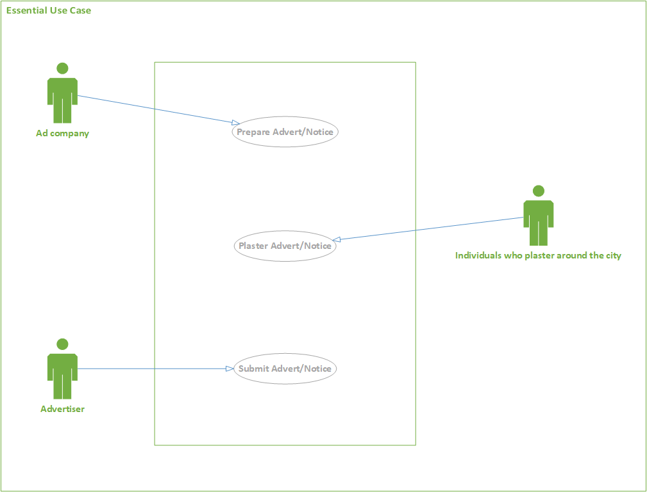

**Figure 2: Essential use case diagram**

#### **4.1.2 Use case documentation**

|  |
| --- |
| **Name:** Prepare advert/notice  **ID**: FPSNEUC-01  **Description:**   * The advertisement company uses this use case to prepare adverts/notices as per the advertiser’s request.   **Pre-condition:**   * The advertiser must submit the contents of the advert * The advertiser must tell the type of the advert/notice (Video, banner, paper). * The advertiser must tell the size of the advert/notice. * The advertiser must tell number of copies needed. * The advertiser must tell the posting area.   **Post-condition:**   * Prepare the requested advert/notice successfully.   **Actors:**   * Advertisement Company, advertiser. |
| **Basic course of action:**   1. Design the advert/notice using variety of designing tools like Photoshop. 2. Make sure if the advertiser likes the advert/notice design. 3. Print the designed advert/notice. 4. Use case ends.   **Alternative course of action:**   * If the advertiser doesn’t like the advert/notice design.   A2. Re-design the advert/notice.  A3. Make sure if the advertiser likes the re-designed advert/notice.  A4. Print the designed advert/notice.  A5. Use case ends. |

**Table 17: FPSNEUC-01**

|  |
| --- |
| **Name:** Plaster advert/notice  **ID**: FPSNEUC-02  **Description:**   * Individuals who are hired either by the advertisement company or the advertiser plaster the printed advert/notice all around the city with price of 1 ETB/paper.   **Pre-condition:**   * The advertisement company must give finished advert/notice. * The advertiser must notify the area where he/she want the advert/notice to be posted. * Glue and transportation allowance. * The advertiser must tell the size of the advert/notice. * Deal with the advertiser about the duration of the billboard.   **Post-condition:**   * Post the advert/notice on the areas requested by the advertiser successfully.   **Actors:**   * Advertisement Company, advertiser, individuals who plaster advert/notice around the city. |
| **Basic course of action:**   1. Travel to the area requested by the advertiser. 2. Plaster the advert/notice as requested. 3. Use case ends.   **Alternative course of action:**   * If the advertiser requests the advert/notice to be posted as a billboard.   A1. Post the advert/notice on the requested area.  A2. Maintain the billboard if the advert/notice is getting torn.  A3. When the time dealt with the advertiser is up remove the billboard.  A4. Use case ends.   * If the advertiser requests the advert/notice to be posted on privately owned notice boards.   A1. Deal with the notice board owning companies about the duration.  A2. Post the advert/notice on the notice board.  A3. Use case ends. |

**Table 18: FPSNEUC-02**

|  |
| --- |
| **Name:** Submit advert/notice  **ID**: FPSNEUC-03  **Description:**   * The advertiser submits the advert/notice or tells the advertisement company what the advert/notice should look like to be designed.   **Pre-condition:**   * The advertiser must submit the contents of the advert. * The advertiser must tell the size of the advert/notice. * The advertiser must tell number of copies needed. * The advertiser must tell the posting area.   **Post-condition:**   * Prepare the requested advert/notice successfully.   **Actors:**   * Advertisement Company, advertiser. |
| **Basic course of action:**   1. Submit the advertisement in person to the advertisement company. 2. Make sure if the advertisement is in order. 3. Deal on the date when the advert will be ready. 4. Use case ends. |

**Table 19: FPSNEUC-03**

* 1. **Essential UI prototype and UI flow diagram**

#### **Essential UI prototype**

**Essential User Interface prototype for Home page.**

**Figure 3: Essential UI for home page**

Input field for search

Register and Login requesters

Search Requester

Logo

Details about Sheger Notice

(Display only)

ADVERTISER

NOTICE

Ads

(Display only)

Sheger Notice copy right

(Display only)

**Essential User Interface prototype for Login.**

**Figure 4: Essential UI for login**

**Advert**

(Requester)

**Notice**

(Requester)

Sign in requester

Cancel

Input field for password

Input field for username

Register and Login Requester

Search requester

Input field for search

Logo

**Essential User Interface prototype for Register.**

Input field for Email

Input field for phone

Input field for address

Input field for first name

Input field for last name

Input field for username

Submit requester

Input field for password

**Figure 5: Essential UI for register**

Register and Login requester

Search requester

Input field for search

Logo

**Essential User Interface prototype for contact.**

Input requester

Input field for message

Input field for email

Input field for name

Register and login

Requester

Search requester

Input field for search

Logo

**Figure 6: Essential UI for contact**

**Essential User Interface prototype for about us.**

Register and Login

Requester

**Figure 7: Essential UI for about us**

Vision of our company

(Display only)

Mission of our company

(Display only)

Search requester

Input field for search

Logo

**Essential User Interface prototype for submit advert/notice.**

Register and Login requester

**Figure 8: Essential UI for submit advert/notice**

Submit requester

Input field for uploading file

Input field for file format

Input field for company name

Search requester

Input field for search

Logo

**Essential User Interface prototype for payment.**

Register and login requester

**Figure 9: Essential UI for payment**

Pay requester

Input field for payment means

Input field for phone

Input field for address

Input field for duration

Input field for amount

Input field for payment receiver

Input field for company name

Input field for name

Search requester

Input field for search

Logo

**Essential User Interface prototype for Advertisement.**

Place holder for News

Place holder for ad image (video)

Place holder for ad image (video)

Register and login requester

Search requester

Input field for search

LOGO

**Figure 10: Essential UI for advertisement**

**Essential User Interface prototype for Notice.**

Place holder for News

Place holder for notice image (video)

Place holder for notice image (video)

Register and login requester

Search requester

Input field for search

LOGO

**Figure 11: Essential UI for notice**

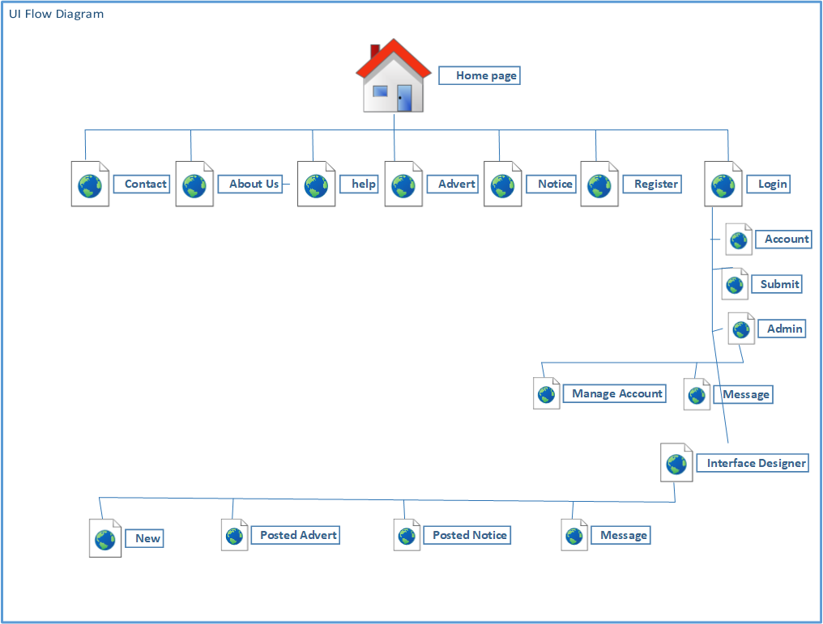

**Figure 12: UI flow diagram**

### **4.3CRC Modeling**

A Class Responsibility Collaborator (CRC) model is a collection of standard index cards that have been divided into three sections. (Beck & Cunningham 1989; Wilkinson 1995; Ambler 1995). A class represents a collection of similar objects, a responsibility is something that a class knows or does, and a collaborator is another class that a class interacts with to fulfill its responsibilities.

|  |  |
| --- | --- |
| **Advertiser**  **<<actor>>** | |
| Advertiser ID  Name  Address  Phone number  Send advert/notice | Advert  Notice |

|  |  |
| --- | --- |
| **Visitor**  **<<actor>>** | |
| Send comment  View advert/notice | Advert  Notice |

|  |  |
| --- | --- |
| **Advert**  **<<UI>>** | |
| Advert ID  Advert category  Posting date  Advertiser | Visitor  Advertiser |

|  |  |
| --- | --- |
| **Register**  **<<UI>>** | |
| Name  Address  Phone number  Password  Username | Advertiser  Register  Database developer |

|  |  |
| --- | --- |
| **Notice**  **<<UI>>** | |
| Notice ID  Notice category  Posting date  Expiry date  Advertiser | Visitor  Notice sender |

|  |  |
| --- | --- |
| **System analyst**  **<<actor>>** | |
| Id  Name  Address  Title | Visitor |

|  |  |
| --- | --- |
| **Make payment**  **<<UI>>** | |
| Advert/notice ID  Advertiser Name  Advertiser Address | Project manager  Advert  Notice |

* 1. **Supplementary Specification**

#### **4.4.1 BUSINESS RULE**

A business rule defines or constrains one aspect of your business that is intended to assert business structure or influence the behavior of your business. Business rules often focus on access control issues. Business rules may also pertain to business calculations and the policies of your organization.

**Name: Logging in to the web site**

**ID: BR #01**

**Description/rule:** No user of the web page can be logged in unless they are advertiser/notice teller.

**Name: Posting on the web page.**

**ID: BR #02**

**Description/rule:** No user/viewer or advertiser/tell notice can post any content directly to the web page.

**Name: Editing the web page**

**ID: BR #03**

**Description/rule:** No user/viewer or advertiser/notice teller can edit the content of the web page. However, can claim editing with his or others advert or notice if its write is infringed.

**Name: Deleting contents of the web page**

**ID: BR #04**

**Description/rule:** No user/viewer or advertiser can delete the contents of the web page. However, he can claim deletion if his or others write are infringed.

**Name: updating the contents of the web page**

**ID: BR #05**

**Description/rule:** No user/viewer or advertiser can update the contents of the web page. However, he may claim updating on his own advertisement/notice.

**Name: confirming the contents of the web page**

**ID: BR #06**

**Description/rule:** The task of confirming the contents of the web page is interface the designer.

**Name: Format of the web pages**

**ID: BR #07**

**Description/rule:** format of the website can be text, pictures and sound, videos and sound, animation and sound.

**Name: Format/content**

**ID: BR #08**

**Description/rule:**  The content that should be submitted by the the advertisermust be**:**

1. Text= specified by the designer.
2. Sound= 320 bit/rate /MP3
3. Video= HD (720 x 1280 px)/MP4.
4. Animation= HD (720 x 1280 px)/MP4.

**Name: payment for service**

**ID: BR #09/1**

**Description/rule:** Payment for service done only if the advertisement/notice are confirmed.

**Name: Amount of payment for service (pricing)**

**ID: BR #09/2**

**Description/rule:** pricing shall be calculated as:

1. Text=20 char= 0.50
2. Sound=0.75
3. Picture= 9,192 byte=1.00 Birr
4. Video= 9,744,384 byte = 2.00 Birr
5. Animation= 9,744,384 byte = 2.00 Birr

**Name: proving payment**

**ID: BR #10**

**Description/rule:** Payment shall be proved by receipt.

**Name: Registering to the web site**

**ID: BR #11**

**Description/rule:** Only advertisers or/and notices tellers may register on the website.

**Name: power and duties**

**ID: BR #12**

**Description/rule:** The website has full power to delete, update, edit, and suspend the content of the advertisement/notice when necessary.

**Name: Content and Presentation of Advertisement**

**ID: BR #13**

**Description/rule:** The following advertisement/notice should not be confirmed or displayed in the website:

a) Contents contrary to the law or moral;

b) Contents should be free from misleading or unfair statements;

c) Respect the social and traditional values of the society and not infringe the legitimate interests of consumers.

d) Describe the true nature, use, quality and other similar information of the product or service intended to be promoted.

e) Not undermine the commodities or services of other persons.

f) Protect the dignity and interests of the country.

g) Respect professional code of conduct.

**Name: Eligible to register**

**ID: BR #14**

**Description/rule:** Any business that has legal personality and can engaged in legal activities in the territory of Ethiopia shall be eligible for registration.

**Name: Detraining eligibility to register.**

**ID: BR #15**

**Description/rule:** Any business or person, with a legal document that proves its legal personality is eligible for register.

**Name: Unlawful or Immoral Advertisement/notice**

**ID: BR #16/1**

**Description/rule:** Advertisement that contains pictures, sound or comparisons that violates the dignity, liberty or equality of mankind in relation to language, gender, race, nation, nationality, profession, religion, and belief, political or social status cannot be posted on the web site.

**ID: BR #16/2**

**Description/rule:** Advertisement that violates the rules of good behavior or human dignity of individuals, nation, nationalities or peoples, and defames the reputation of an organization;

**ID: BR #16/3**

**Description/rule:** Advertisement that undermine the national or regional state’s flag, emblem, national anthem or currency;

**ID: BR #16/4**

**Description/rule:** Advertisement that undermine the dignity or emotional feeling of physically disabled person or a person living with HIV/AIDS or suffering from other disease;

**ID: BR #16/5**

**Description/rule:** Advertisement that instigates chaos, violence, terror, conflict or fear among people;

**ID: BR #12/7**

**Description/rule:** Advertisement that instigate an action that could endanger the physical or mental health and security of the people.

**ID: BR #12/8**

**Description/rule:** Advertisement causing sound pollution through any sound magnifying machine, which does not comply with the sound limit set by the appropriate governmental body;

**ID: BR #12/9**

**Description/rule:** Advertisement with obscene written message, image, picture, film or similar presentation;

**ID: BR #12/10**

**Description/rule:** Advertisement using the name, image or photograph of a person without his consent, or artistic or creative works protected by the law without authorization by the concerned person;

**ID: BR #12/9**

**Description/rule:** Advertisement contrary to traffic safety or environmental protection;

**ID: BR #12/10**

**Description/rule:** Commercial advertisement presented by wearing defense force or police uniforms, decorations or insignia;

**ID: BR #12/11**

**Description/rule:** Advertisement with content or presentation prohibited by other laws or that promotes the violation of any law.

Name: **Advertisement Requiring Special Certification**

**ID: BR #13/1**

**Description/rule:** Prior certification by the appropriate body shall be required in order to promote products or services that have to meet mandatory standard requirements.

**ID: BR #13/2**

**Description/rule**: An advertiser who is required to obtain a certificate of competence or a business license may not advertise its product or service without obtaining such certificate or license from the appropriate body.

**Name: Advertisements Affecting Minors**

**ID: BR #14/1**

**Description/rule:** An advertisement that may harm the attitude, feeling or thinking of a minor.

**ID: BR #14/2**

**Description/rule:** An advertisement that may cause a minor to lose affection or trust in his family, guardian, tutor, teacher, society or country.

**ID: BR #14/3**

**Description/rule:** An advertisement that openly motivates a minor to require his parent, guardian, tutor or any other person to buy the advertised product or service.

**ID: BR #14/4**

**Description/rule:** An advertisement, which directly or indirectly provides a misleading price and gives impression to a minor that the product or service advertised is affordable to any family.

**ID: BR #14/5**

**Description/rule:** An advertisement causing inferiority complex to a minor that did not buy the advertised product or service, by portraying that the one who does is better than the one who does not.

**ID: BR #14/6**

**Description/rule:** An advertisement that demonstrates, through mixing of sounds, writings and pictures, a minor while doing any action contrary to law or moral, or being in a dangerous situation or place;

**ID: BR #14/7**

**Description/rule:** An advertisement that uses a minor as an advertisement presenter or actor without the consent of his guardian or tutor;

**ID: BR #14/8**

**Description/rule:** Any other advertisement having similar content or presentation

**Name: Counter Advertisement**

**ID: BR #15/1**

**Description/rule:** The advertiser, the advertising agent and the advertisement disseminator shall disseminate a counter advertisement in favor of the victim of any advertisement that in breach.

**ID: BR #15/2**

**Description/rule:** Unless otherwise contrary evidence is presented, the advertiser, the advertising agent and the advertisement disseminator shall be jointly and severally liable to cover the cost of the counter advertisement.

**ID: BR #15/3**

**Description/rule:** A counter advertisement shall be arranged and disseminated in the same method, duration and place as the original advertisement was disseminated.

**Name:**  **Prohibited Advertisement**

**ID: BR #16/1**

**Description/rule:** Advertisement of any substance classified as narcotic drug by appropriate governmental body.

**ID: BR #16/2**

**Description/rule:** advertisement that encourage the direct use of any prescription medicine or medical appliance.

**ID: BR #16/3**

**Description/rule:** Advertisement of narcotic drug or psychotropic substance.

**ID: BR #16/4**

**Description/rule:** advertisement of weapon.

**ID: BR #16/5**

**Description/rule:** advertisement of gambling.

**ID: BR #16/6**

**Description/rule:** Advertisement of illegal product or service

**ID: BR #16/7**

**Description/rule:** Advertisement of usury.

**ID: BR #17/8**

**Description/rule:** Advertisement of witchcraft.

**ID: BR #16/9**

**Description/rule:** Advertisement of cigarette or other tobacco products.

**ID: BR #16/10**

**Description/rule:** Advertisement having political goals.

**ID: BR #16/11**

**Description/rule:** Other advertisements prohibited by law.

**Name:**  **Restricted Advertisement**

**ID: BR #17/1**

**Description/rule:** Any advertisement of liquor with more than 12% alcoholic content may not be disseminated directly or indirectly through any means of dissemination.

**ID: BR #17/2**

**Description/rule:** Advertise that consumption of the liquor is good for health, brings about individual or social success, improves psychological or physical strength or provides healing power, or instigate its repeated consumption or over drinking;

**ID: BR #17/3**

**Description/rule:** undermine or oppose abstention from alcohol addiction;

**ID: BR #17/4**

**Description/rule:** Concentrate on minors, or use a minor as an advertisement actor;

**Name: obligation of advertiser and advertisement disseminator.**

**ID: BR #18/1**

**Description/rule**: To verify the correctness of an information provided to it by an advertiser;

**ID: BR #18/2**

**Description/rule:** To require the advertiser to make adjustments to an advertisement where it breaches the law if disseminated as presented.

**ID: BR #18/3**

**Description/rule:** Any advertiser shall have the obligation to submit evidence requested by an advertising agent or disseminator to verify the correctness of an information included in an advertisement.

**Name: Cancelation**

**ID: BR #19**

**Description/rule:** The website may cancel the contract concluded with the advertiser and claim damages if the advertiser is unwilling or unable to fulfill the requirement

**Name: Record Keeping and Providing Information**

**ID: BR #20/1**

**Description/rule:** the website shall have the obligation to make a copy of a disseminated advertisement and keep a record of it at least for six months.

**ID: BR #20/2**

**Description/rule:** The website, when requested by the Authority or the appropriate government body in connection with the enforcement of the law provide, at its own cost, a copy of an advertisement record kept.

**Name: Fair Dissemination of Advertisements**

**ID: BR #21**

**Description/rule:** the website shall disseminate impartially and fairly advertisements submitted to it by advertisers and advertising agents.

**Name**: **Responsibilities of Advertiser, Advertising Agent and Advertisement Disseminator**.

**ID: BR #22**

**Description/rule:** Unless proved to the contrary, any advertisement disseminated in breach of the law shall be presumed to have been conducted with the consent of the advertiser, advertising agent and advertisement disseminator, and they shall be jointly and severally liable according to their degree of responsibility.

#### **4.4.2 Constraints**

|  |  |
| --- | --- |
| **Constraint ID** | **Description** |
| Con-01 | Lack of funding |
| Con-02 | Many competition in the market |
| Con-03 | The system will only use the data provided from the internal database |
| Con-04 | The system should be available at every given time |

**Table 20: Constraints**

#### **4.4.3 Change case**

Change cases are used to describe new potential requirements for a system or modifications to existing requirements. Change cases can be identified throughout the course of our overall development efforts.

Below is a list of change cases regarding our system: -

**Change case-01**: The adverts/notices grow in number

**Likelihood**: Certain, a long term plan of the project (system)

**Impact**: Small, since this is a long term plan no new modification to the system will be made to the system in the near future.

**Change case-02:** The advertisement law change

**Likelihood:** Certain, in the future the countries law on advertisement will change

**Impact:** Small, since this is likely to happen in a long term the impact is most likely minimum.

**Change case-03:** Introduction of new technology

**Likelihood:** Certain, advancement of technology is moving on a very high pace

**Impact:** large, advancement of technology in a short period of time will make the system out of date and needs an update or even rethinking the whole design of the system.

## **5. Analysis System Models**

### **5.1 System use case modeling**

#### **5.1.1 System use case modeling**

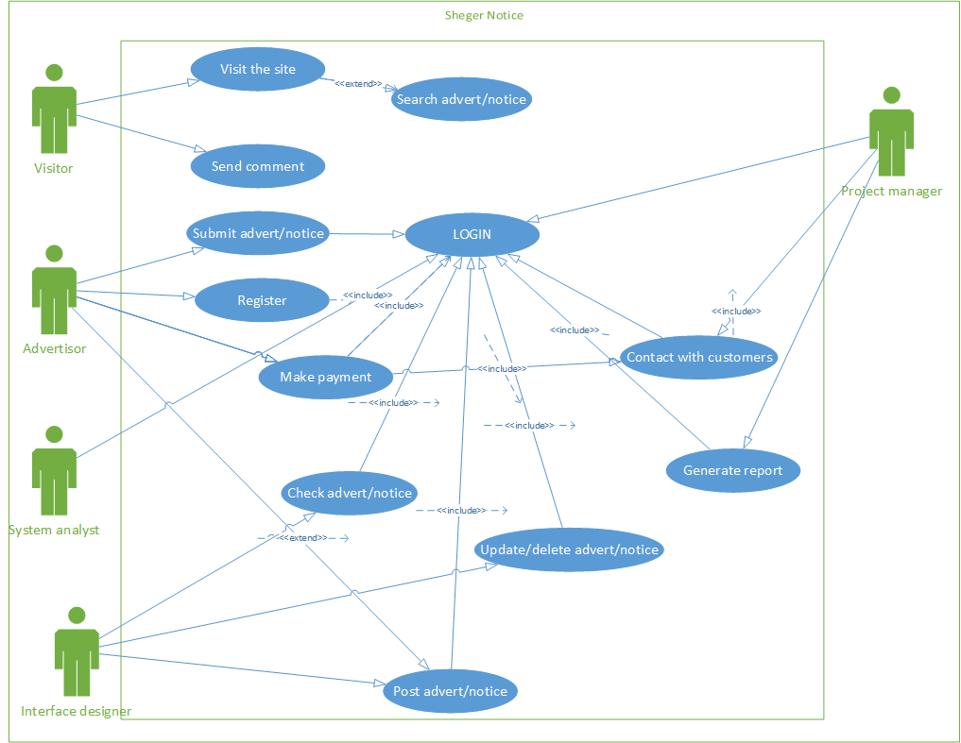

**Figure 13: System use case**

#### **5.1.2 System use case documentation**

|  |
| --- |
| **Name: Post advert/notice**  ID: FPSN-01  **Description:**   * The interface designer uses this use case to post advert/notice on the site   **Preconditions:**   * The submitted advert/notice is in compliance with the standards of the company.   **Post conditions:**   * Post the submitted advert/notice   **Actors(s):**   * Interface designer, advertiser   **Include(s):**   * Login |
| **Basic course of action**   1. The interface designer checks the category of the advert/notice to be posted using the check advert/notice category UI. 2. System returns the advert/notice category by fetching the category from the table. 3. The interface designer checks the due date of the advert/notice (expiry date) using the check advert/notice due date UI. 4. System returns the due date by fetching from the database. 5. The interface designer posts the advert/notice according to the category, due date and size using the post advert/notice UI. 6. System sends notification to the advertiser. 7. The advertiser gets a notification via a message and view the message using the messages UI. 8. Use case ends |

**Table 21: FPSN-01**

|  |
| --- |
| **Name: Check advert/notice**  ID: FPSN-02  **Description:**   * The interface designer uses this use case to check the submitted advert/notice by the advertiser   **Preconditions:**   * Know the standards of the company * Know the business rule of the company   **Post conditions:**   * Check advert/notice submitted by the advertiser   **Actors(s):**   * Interface designer |
| **Basic course of action**   1. The interface designer checks the advert/notice is in compliance with the company’s standards using the check advert/notice UI. 2. The interface designer checks if the due date has been set using the check advert/notice UI. 3. The interface designer checks if the category is set using the check advert/notice UI. 4. The interface designer prepares the advert/notice for posting using the advert/notice UI. 5. Use case ends   **Alternative course of action**  **Name:**   * The advert/notice is not in compliance with the company’s standards   A1. The interface designer notifies the advertiser by sending a message using the message UI.  A2. Use case ends   * The due date is not set.   A2. The interface designer notifies the advertiser and remind to set the due date or check for how long the advert is going to be displayed by sending a message using the message UI.  A3. Use case ends.   * The category is not set.   A3. The interface designer notifies the advertiser and remind to set the category by sending message using the message UI.  A4. Use case ends. |

**Table 22: FPSN-02**

|  |
| --- |
| **Name: Contact with customers**  ID: FPSN-07  **Description:**   * This use case is used by the project manager to contact with the customers/advertisers.   **Preconditions:**   * Find the contact information of the customer. * Go to the contact with customer’s page.   **Post conditions:**   * Reach the customer by their address   **Actors(s):**   * Project manager |
| **Basic course of action**   1. The project manager in puts the contact info of the customer using the contact customer UI. 2. The project manager sends message using the message UI. 3. Use case ends. |

**Table 23: FPSN-07**

|  |
| --- |
| **Name: Update advert/notice**  ID: FPSN-05  **Description:**   * This use case is used by the interface designer to update/delete advert/notice   **Preconditions:**   * Login in to the site * Go to the interface designers page   **Post conditions:**   * Update/delete advert/notice   **Actors(s):**   * Interface designer |
| **Basic course of action**   1. The interface designer gets any update info. or data from the advertiser about the advert/notice using the update UI. 2. The interface designer updates the submitted new data/info. from the advertiser using the update UI. 3. System shows confirmation message. 4. Use case ends   **Alternative course of action**  **Name:**   * No update is received from the advertiser about the advert/notice   A1. No updating will be done  A2. Use case ends  **Name:**   * If an advert is incompliance with the standards of the company   A3. No deletion will be done  A4. Use case ends |

**Table 24: FPSN-05**

|  |
| --- |
| **Name: Generate report**  **ID: FPSN-06**  **Description:**   * This use case is used by the project manager for report generating purposes   **Precondition:**   * Login to the site * Go to the administrator page   **Post condition:**   * Generate reports according to the performance of each departments   **Actor(s):**   * Project manager |
| **Basic course of action:**   1. The project manager checks if all the database tables are being filled as expected using the admin UI. 2. The project manager compiles each reports in to one. 3. The project manager makes sure the report is recorded for future reference 4. Use case ends. |

**Table 25: FPSN-06**

|  |
| --- |
| **Name: Login**  ID: FPSN-11  **Description:**   * This use case is used by Advertiser, programmer, database developer, system analyst, interface designer, project manager to login in to the site.   **Preconditions:**   * Register on the site   **Post conditions:**   * Login in to the site   **Actors(s):**   * Advertiser, system analyst, interface designer, project manager |
| **Basic course of action**   * + - 1. Input username       2. Input password       3. System checks if username and password is correct       4. System redirects to the intended page.       5. Use case ends |

**Table 26: FPSN-11**

|  |
| --- |
| **Name: Make payment**  ID: FPSN-09  **Description:**   * This use case is used by the advertiser to make payment for a submitted advert/notice   **Preconditions:**   * The advert/notice presented by the advertiser must be accepted by the Interface Designer.   **Post conditions:**   * Advertiser must get a formal receipt   **Actors(s): Advertiser, Interface Designer, project manager** |
| **Basic course of action**   1. The Interface Designer sends acceptance report about the advert/notice. 2. The advertiser will receive the amount to be paid. 3. The advertiser will pay the amount either by cash up front or using online banking. 4. Receipt will be issued to the advertiser. 5. Use case ends.   **Alternate course of action**  **Name:**   * The advertiser doesn’t accept the payment methods   A3. Contact with the project manager to come to an understanding of payment mechanism.  A4. Receipt will be issued to the advertiser.  A5. Use case ends. |

**Table 27: FPSN-09**

|  |
| --- |
| **Name: Submit advert/notice**  ID: FPSN-13  **Description:**   * This use case is used by the advertiser to submit advert/notice   **Preconditions:**   * Register * Login * Make sure the advert/notice meet the standards   **Post conditions:**   * Successfully submit the advert/notice   **Actors(s):**   * **Advertiser** |
| **Basic course of action**   1. The advertiser sends an already finished advert/notice using the submit advert/notice UI. 2. System shows a confirmation message. 3. Use case ends |

**Table 28: FPSN-13**

|  |
| --- |
| **Name: Register on the site**  ID: FPSN-14  **Description:**   * This use case is used by the advertiser to register on the site   **Preconditions:**   * Have an email account * Be over 18 years’ old   **Post conditions:**   * Successfully register on the site   **Actors(s):**   * Advertiser |
| **Basic course of action**   1. The advertiser fills all the necessary fields on the register form using the register UI. 2. The advertiser agrees to the terms and conditions using the register UI. 3. System displays a successfully registered message. 4. Use case ends   **Alternative course of action**  **Name:**   * Not filling the necessary fields on the register form   A1. System notifies that all the necessary fields has not been filled.  A2. Use case ends   * Not agreeing to the terms and conditions   A2. System notifies that in order to register he/she must agree to the terms and conditions. |

**Table 29: FPSN-14**

|  |
| --- |
| **Name: Send comment**  ID: FPSN-16  **Description:**   * This use case is used by the visitor to send comments about the site   **Preconditions:**   * Visit the site   **Post conditions:**   * Successfully submit a comment   **Actors(s):**   * Visitor |
| **Basic course of action**   1. Go to the comment submission section 2. Fill the form 3. Enter comment 4. Send the comment 5. System displays sent message 6. Use case ends |

**Table 30: FPSN-16**

|  |
| --- |
| **Name: Search advert/notice**  ID: FPSN-18  **Description:**   * This use case is used by the advertiser and visitor to search for advert/notice   **Preconditions:**   * Go to the site   **Post conditions:**   * Successfully find the requested advert/notice   **Actors(s):**   * Advertiser, visitor |
| **Basic course of action**   1. Enter the keyword for the advert/notice to be searched 2. System returns search results. 3. Go through the fetched adverts/notices 4. Use case ends |

**Table 31: FPSN-18**

|  |
| --- |
| **Name: Visit the site**  ID: FPSN-19  **Description:**   * This use case is used by the visitor to visit the site   **Preconditions:**   * Visit/browse the site   **Post conditions:**   * Successfully visiting the site without any hiccup   **Actors(s):**   * visitor |
| **Basic course of action**   1. Go to the site address 2. Visit the site depending up on the interest of the visitor 3. Use case ends |

**Table 32: FPSN-19**

### **5.2 Sequence diagram**

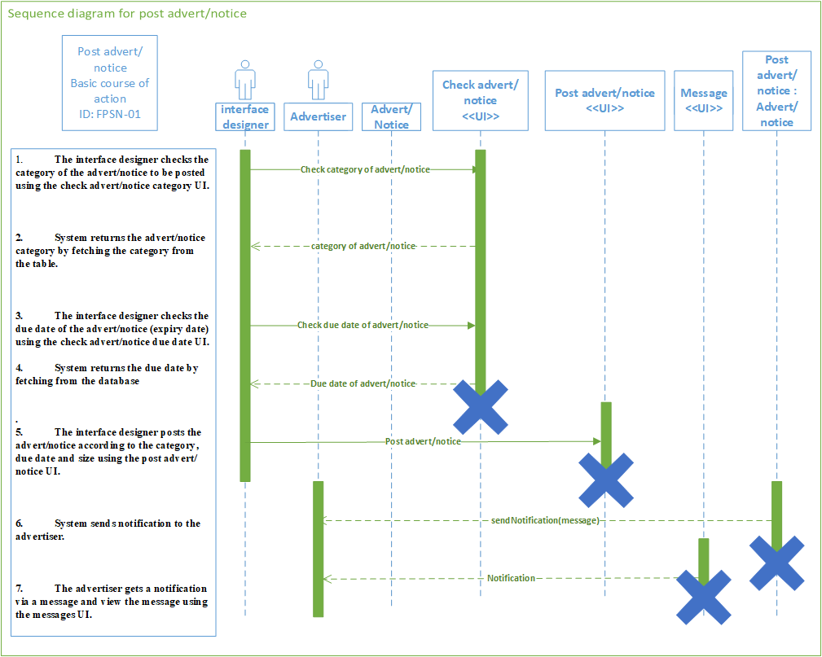

Figure : Sequence diagram for post advert/notice

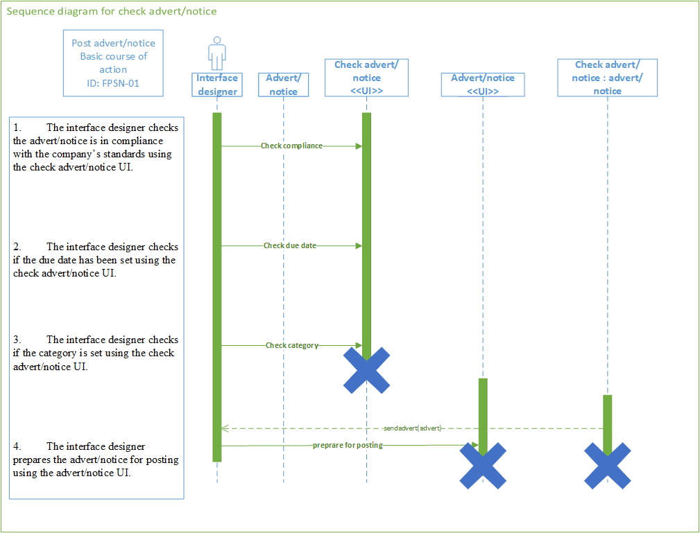

Figure : Sequence diagram for check advert/notice

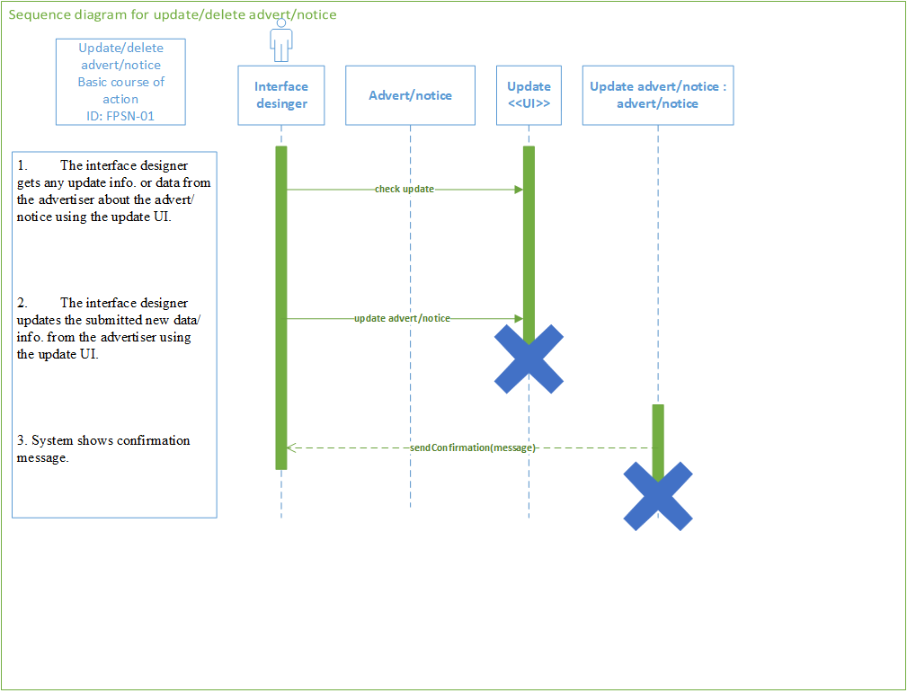

Figure : Sequence diagram for update/delete advert/notice

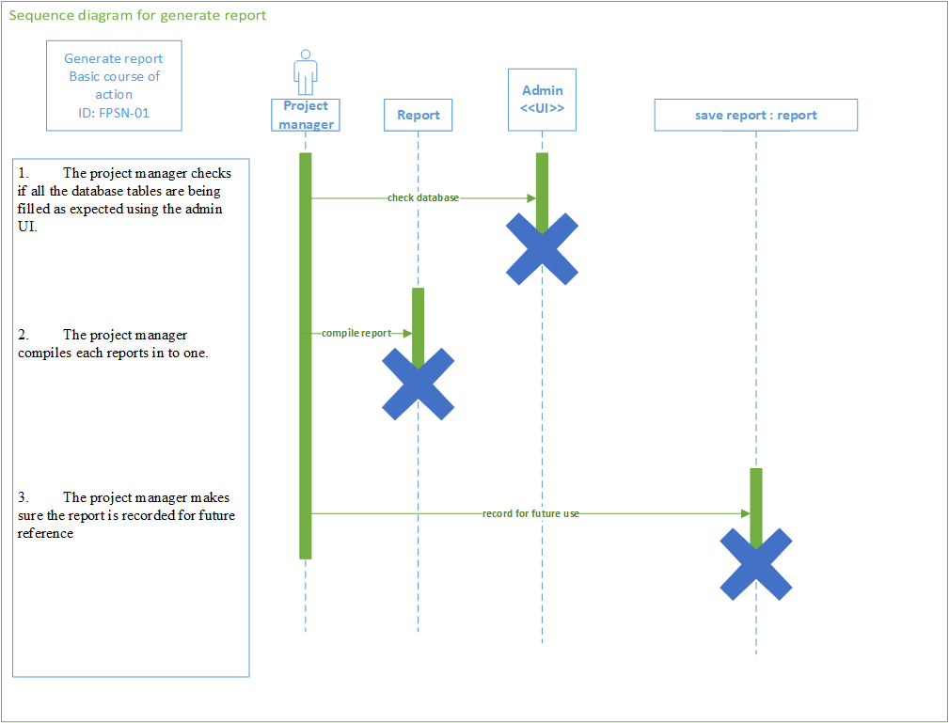

Figure : Sequence diagram for generate report

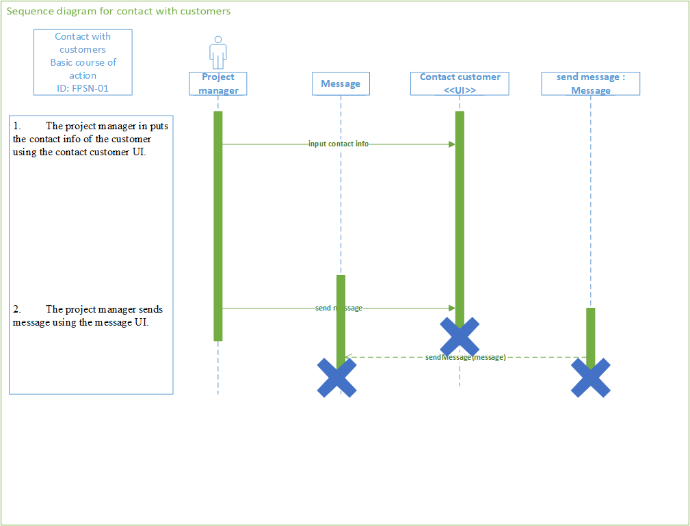

Figure : Sequence diagram for contact with customers

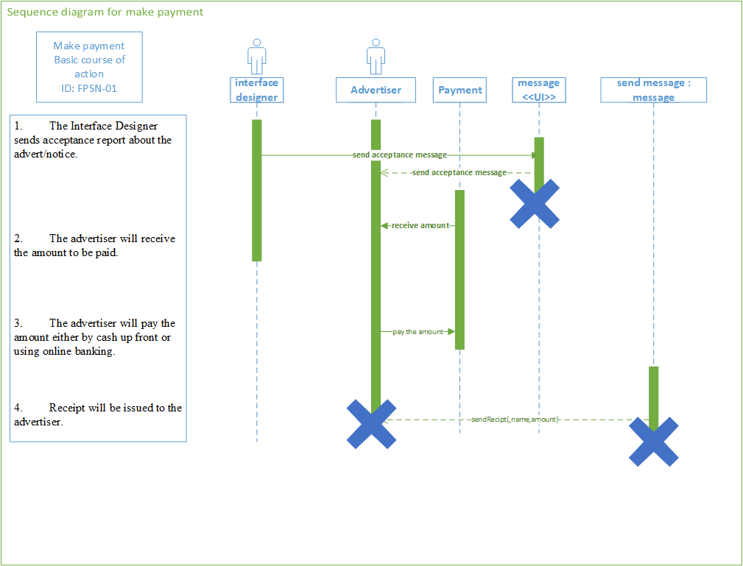

Figure : Sequence diagram for make payment

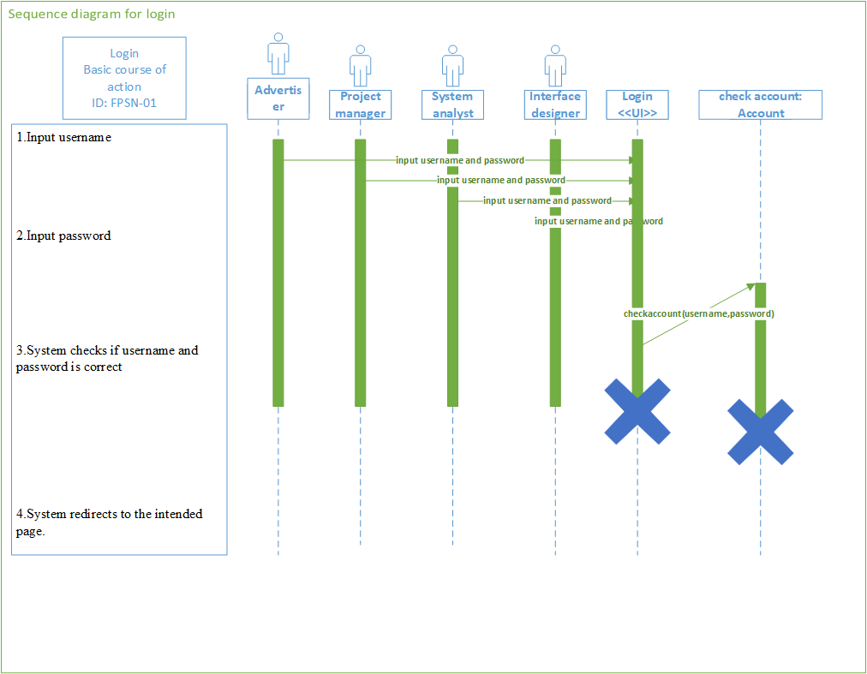

Figure : Sequence diagram for login

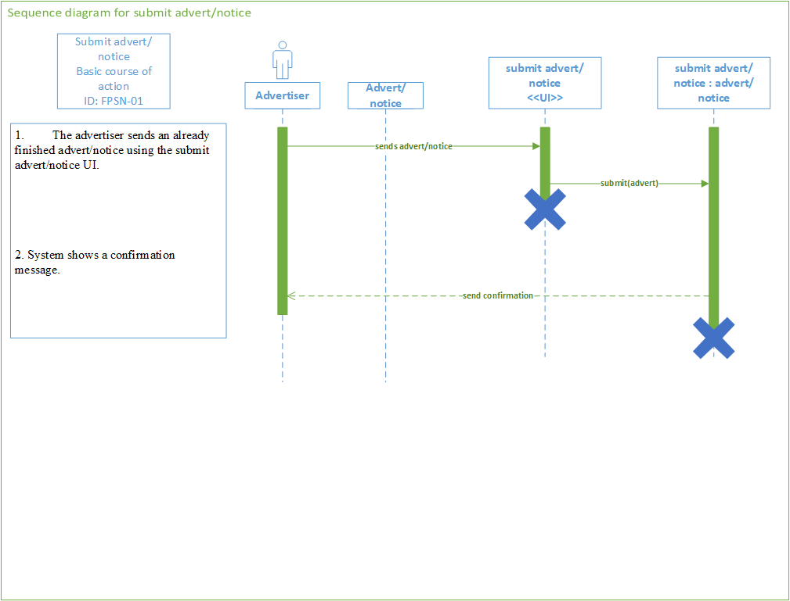

Figure : Sequence diagram for submit advert/notice

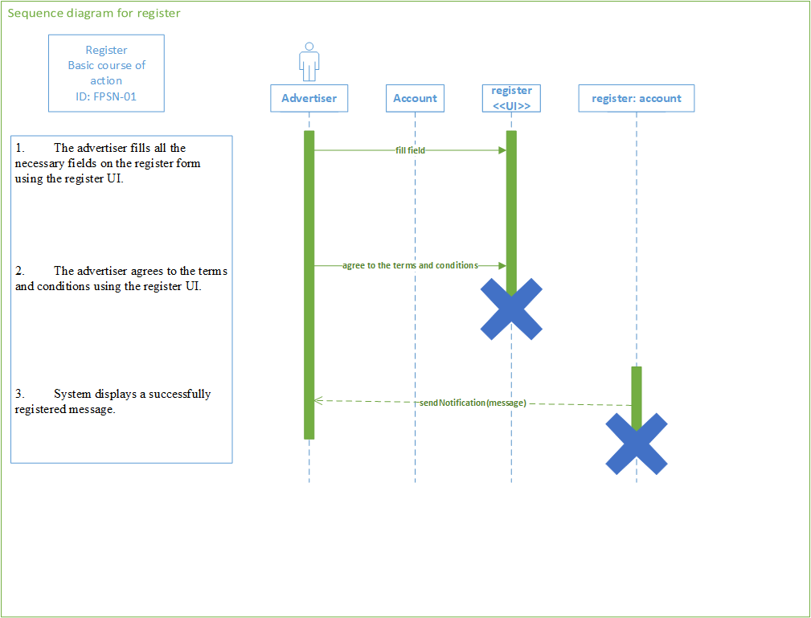

Figure : Sequence diagram for register

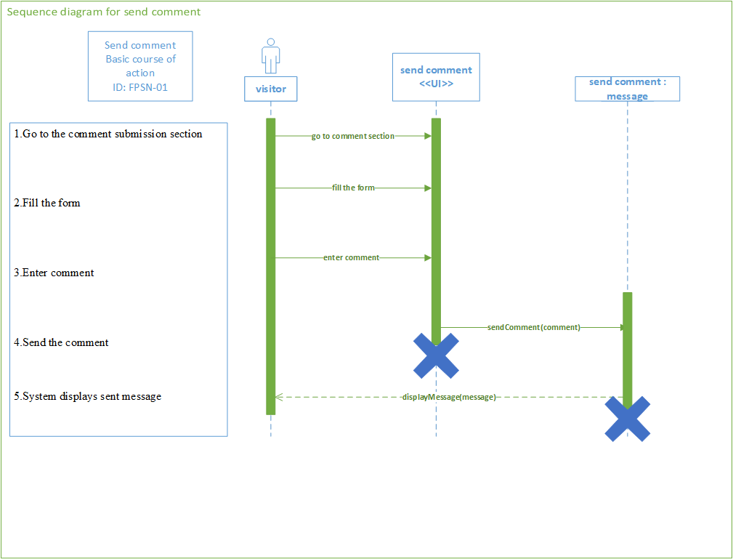

Figure : Sequence diagram for send comment

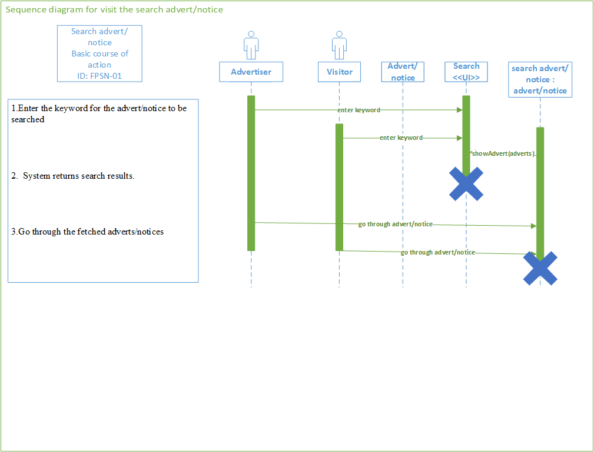

Figure : Sequence diagram for search advert/notice

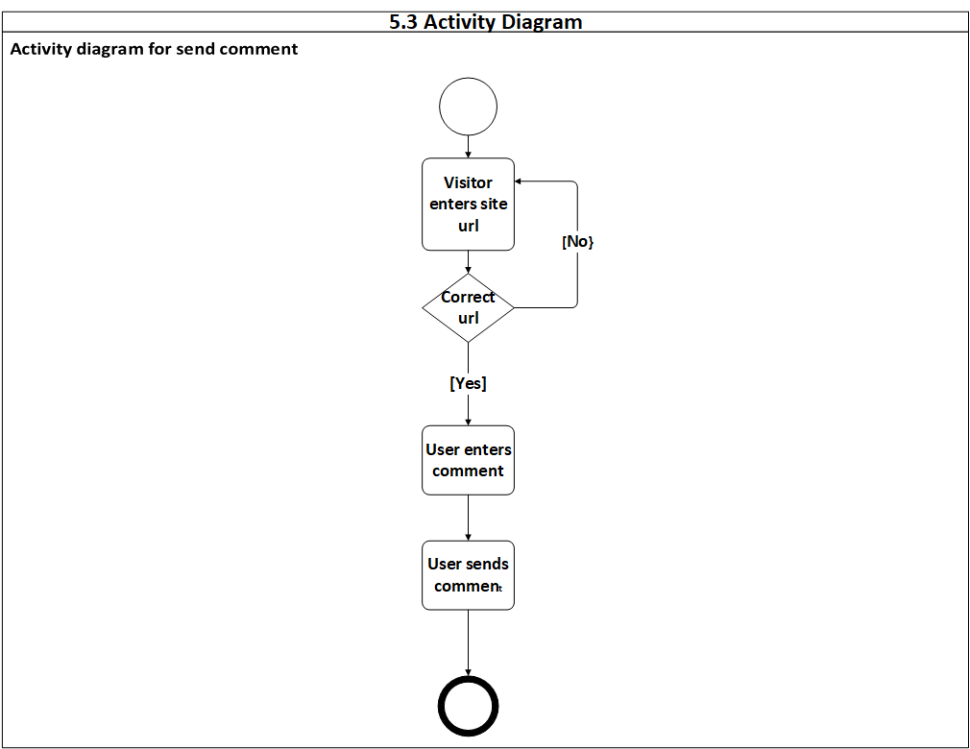

Figure : Activity diagram for send comment

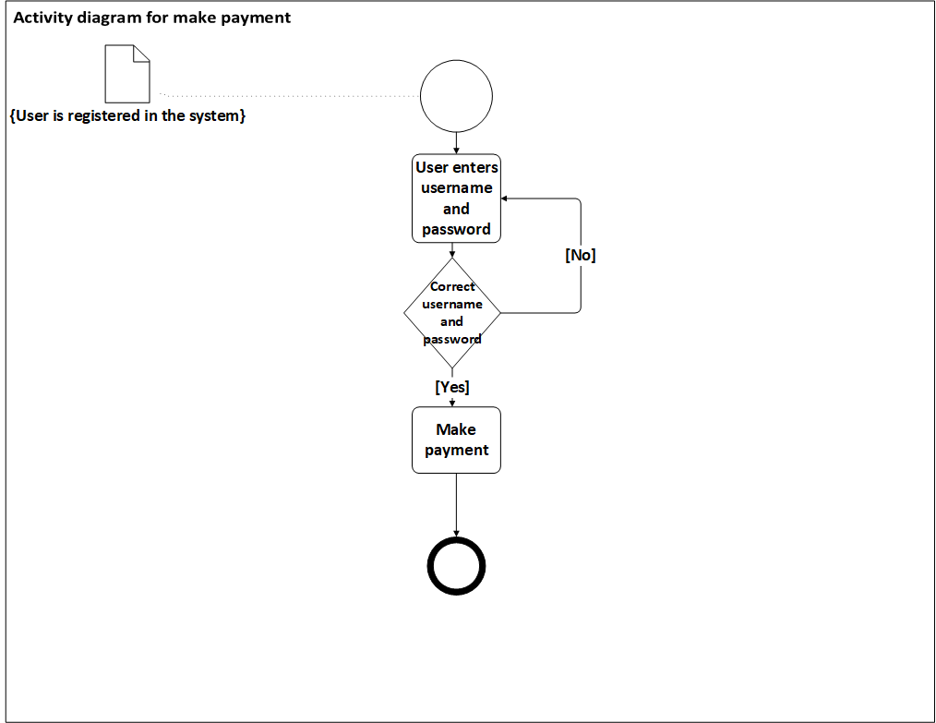

Figure : Activity diagram for make payment

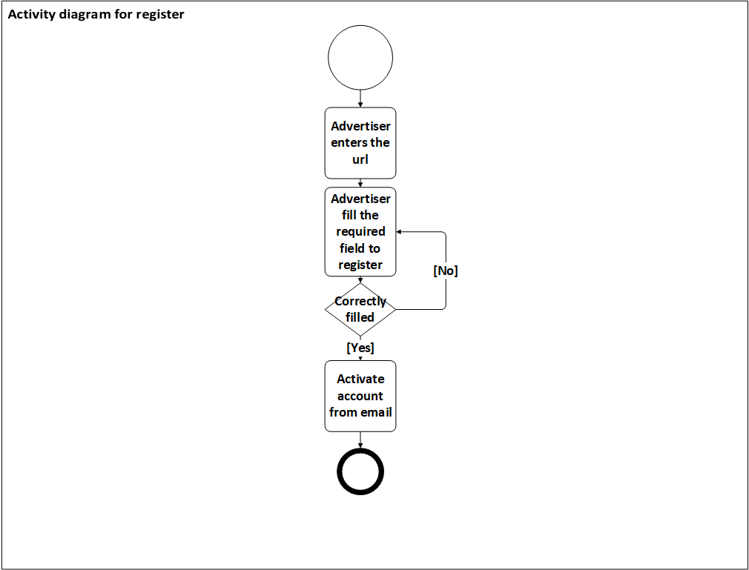

Figure : Activity diagram for register

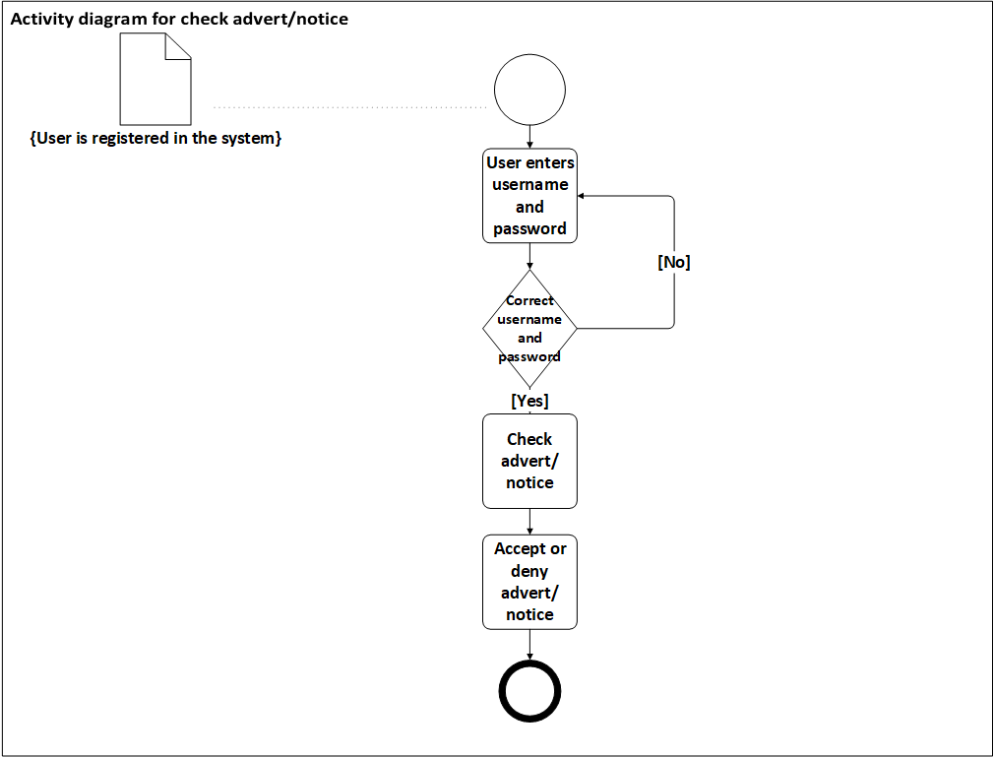

Figure : Activity diagram for check advert/notice

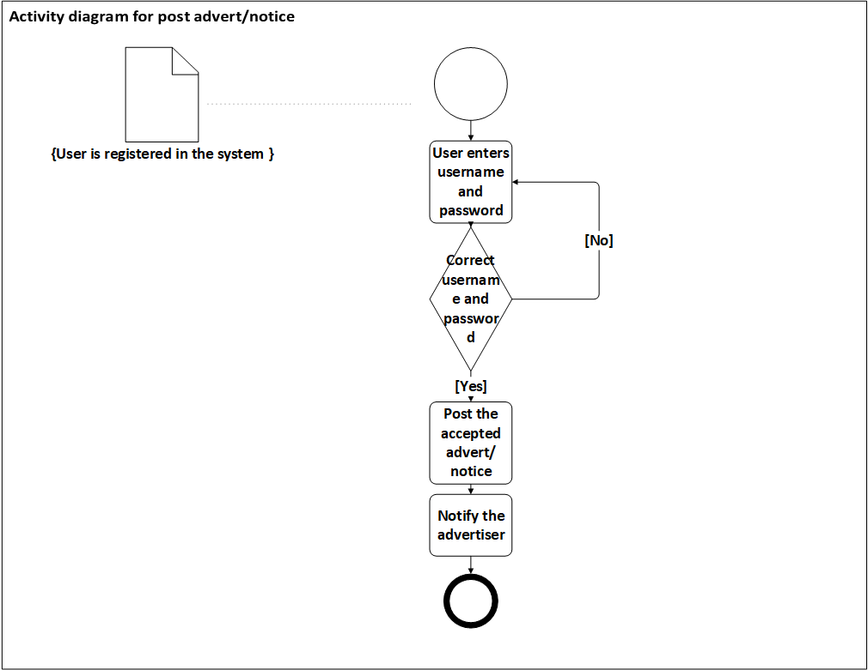

Figure : Activity diagram for post advert/notice

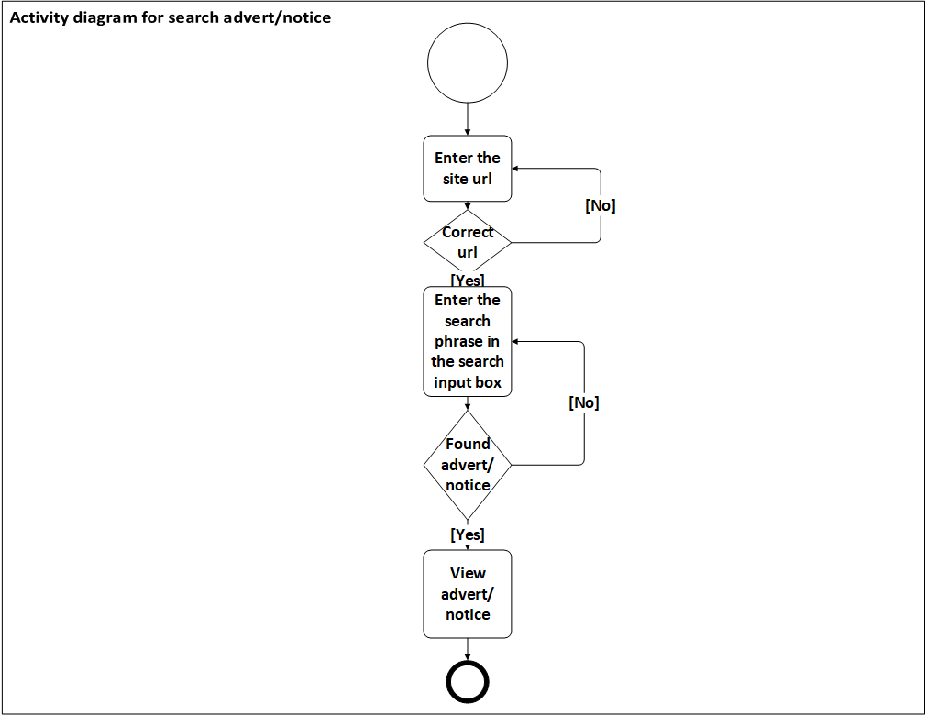

Figure : Activity diagram for search advert/notice

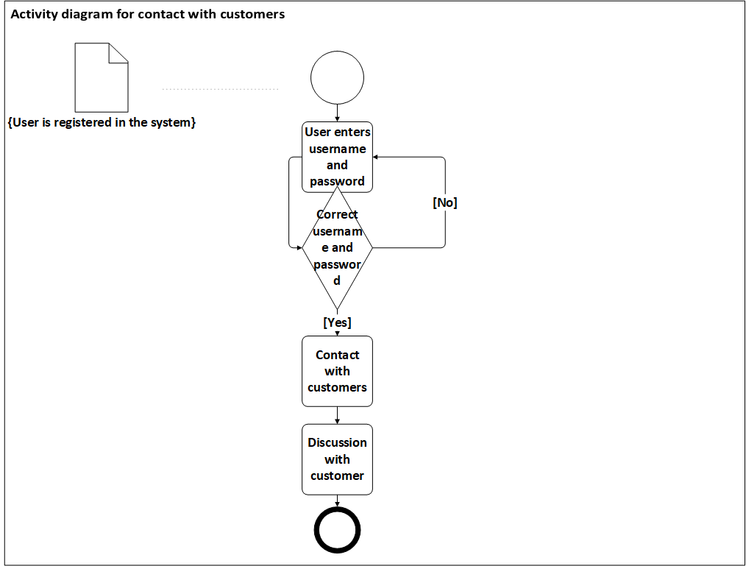

Figure : Activity diagram for contact with customers

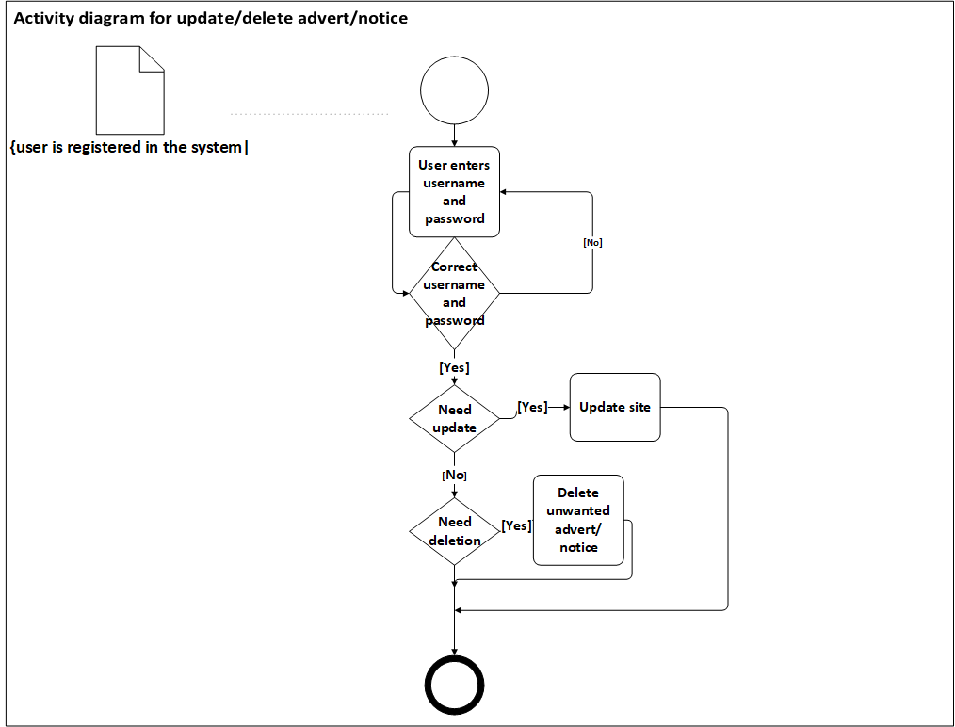

Figure : Activity diagram for update/delete advert/notice

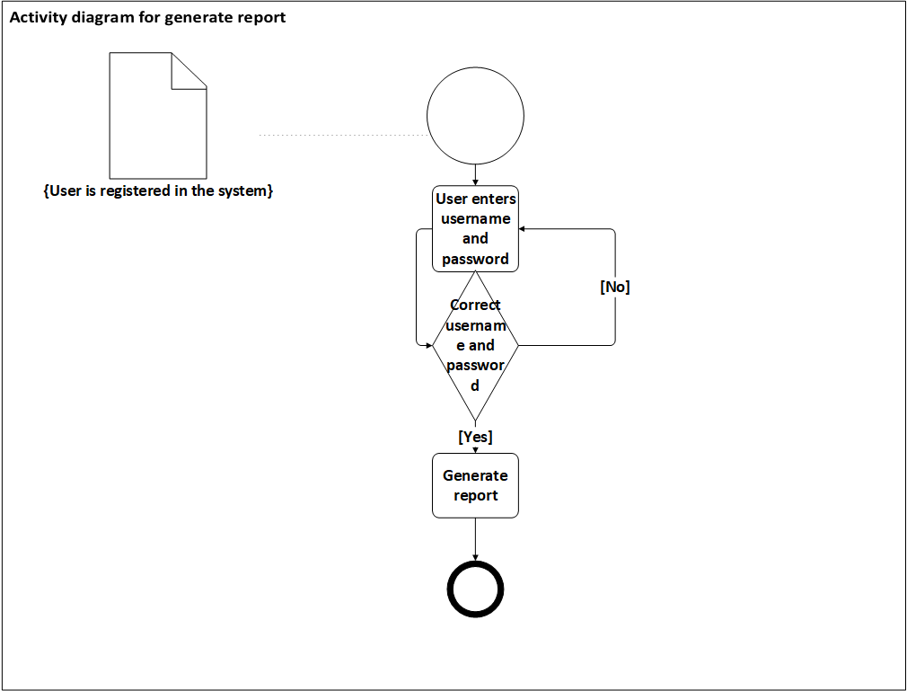

Figure : Activity diagram for generate report

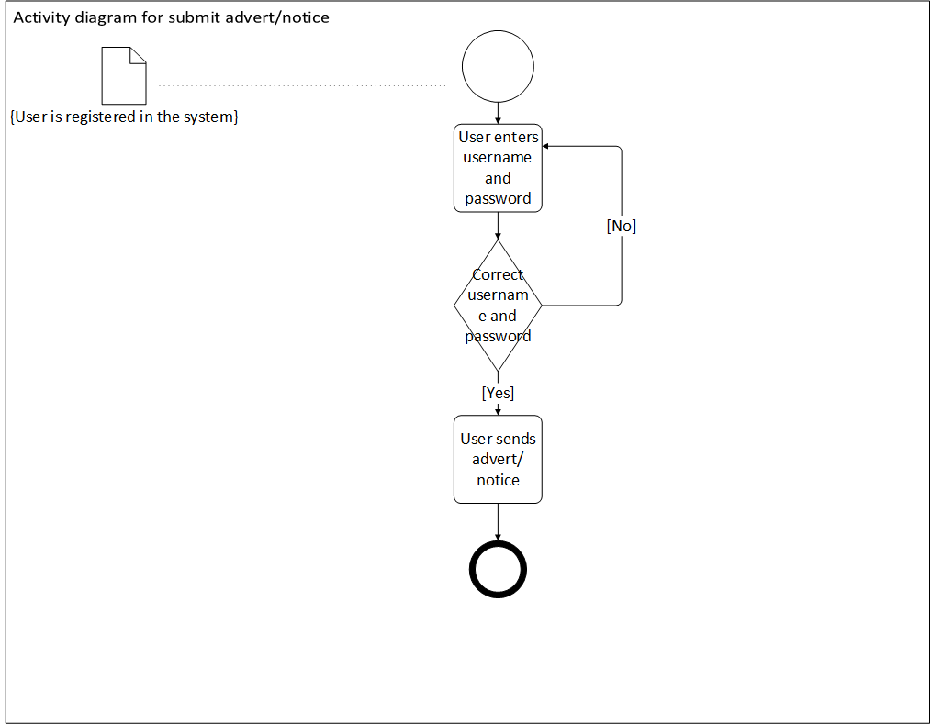

Figure : Activity diagram for submit advert/notice

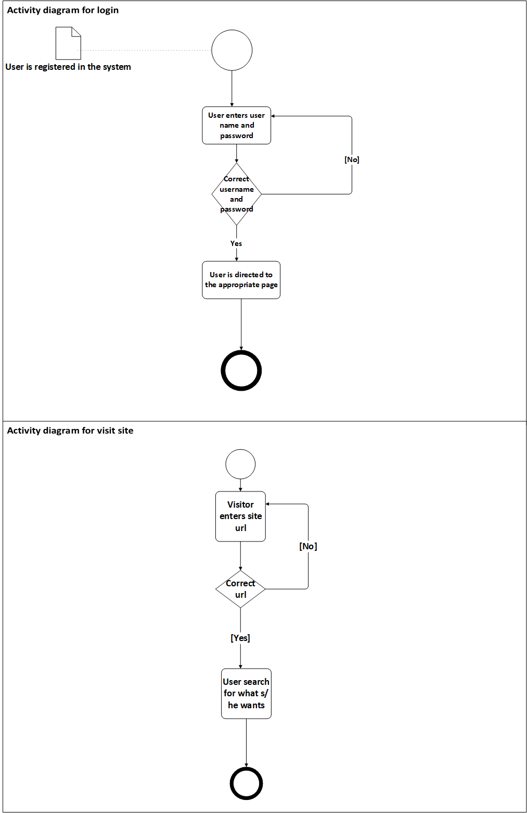

Figure : Activity diagram for login and visit

# **CHAPTER FOUR**

# **SYSTEM DESIGN**

1. **Introduction**

System design is the transformation of the analysis model in to system design model. System Analysis focusses on the application domain while system design focusses on solution domain. The deliverable of this phase is a system design model which serves as a blueprint for the implementation of the system. The system design phase describes desired features and operations in detail, including screen layouts, process diagrams, and other documentation.

1. **Design Goals**

When we first start this project, all the members agree on is that we should use our maximum effort and potential. The design goal of this project should reflect this. As some reference describe the main standards of any web abased site, should contain simplicity, consistency, identity, robustness, navigability, visual appeal, Aesthetic and compatibility. To describe some of them in the context of our project:

**Simplicity**

Simplicity is avoiding exhaustive content, extreme visuals, unpleasant animation, enormous Web pages, complex navigation, and so on. When web site is simple, the simplicity is not only how it is made, but also how it feels to the viewers. The interaction, and the experience the viewers enjoyed on the stay of the site.

**Consistency**

Content should be constructed consistently. In our case, consistency can be text, font, pictures, color, and graphics. These contents should be consistent throughout the site. Navigation mechanisms should be used consistently across all the platform elements. “Remember that to a visitor, a website is a physical place. It is confusing if pages within a site are not consistent in design.”

**Identity**

Sheger notice is a new platform different from other site; therefore, it should have its own identity. The visual, interface, and navigational design of a platform must be consistent with the advertisement/notice for which it is to be built. Therefore, a website for an advert/notice will undoubtedly have a different look and feel than a platform designed for a financial services company.

**Robustness**

Based on the identity that has been established, our web site should make grant to a user it is robust. The user expects robust content and functions that are relevant to the user’s needs. From research, we understood if these elements are missing or insufficient, it is likely that the website will fail.

**Navigability**

Sheger notice is not for professionals only, keeping in mind that the web navigation should be designed in a manner that can be understood by anyone. In other words, it should be intuitive and predictable. That is, the user should understand how to move about the Web without having to search for navigation links or instructions. If navigation from one content to the other is obscure, the user will be frustrated.

**Visual Appeal**

Visual appeal is the look and feel of content, interface layout, color coordination, the balance of text, graphics, and other media, navigation mechanisms. These and other contents contribute to the visual appeal. Web applications are unquestionably the most visual, the most dynamic, and the most Artistic. Especially, when it is an advertisement/ notice it should attract visitors enough so as they are comfortable to spend their time on the site.

**Compatibility**

A web can be used in different hardware, Internet connection, operating systems, and browsers. These variety environments influence the compatibility of the web site. As much as possible we use different mechanisms to consider these and other compatibility issue during the design process.

**Reliability**

We will make sure Sheger notice will have the ability to function as intended, efficiently and without failure. The codes we use the hardware and the software will be upgraded, patched and well maintained to keep the reliability.

**Maintainability**

Sheger notice is a well-documented project; this means all aspects of it well known, this increase the ability to have repairs carried out quickly and efficiently if a failure occurs. It dramatically reduce the effort required to find and fix a fault

**Reusability**

The main objective of object-oriented programming is reusability. Choosing OOP for this project the extent to which the software (or a component within it) can be reused within some other software**.**

**Good documentation**

Our project design goal is to produce the best documentation because, first we would like it to be the stepping stone for others, second we like it to be the standard of all project, and third good documentation improves maintainability, and ease of use.

**Well-defined interface**

Web design is a science and an art. The look and the feel of a web site should be measured and logical, that is a science. Color combinations of each interface is different. Researching which color combination works with which interface is an art. A well-defined interface combines the science, and the art.

**User friendliness**

Sheger notice is for all. User friendliness works for all user, leman and professionals. Our site should be user friendly since it is which any user comfortably to visit and navigate through the web site.

1. **Design tradeoff**

System designers and developers are expected to make decisions of reducing or improving something at the expense of something else for the good of the overall system. This is what we refer to Design trade off.

**Cheap & Fast Accessibility or Cheap Processing Hardware**

Our goal is getting as much as daily users as we can. So, if we compress a video or photo file we can reduce time and internet data cost of our user at the expense of the processing power of the CPU when it compresses and decompresses the file. This way our users can access our site faster with less internet data usage although our processing power might be great, its necessary design trade-off.

**Security or cost**

We are at a time where it is very hard to secure our system and when improving our system security there are many expenses both in money and in time. To secure our system we need top of the line hardware and software plus a very time taking throe configuration and coding. So, this means in this trade off we’re sacrificing our time and money for a better system security.

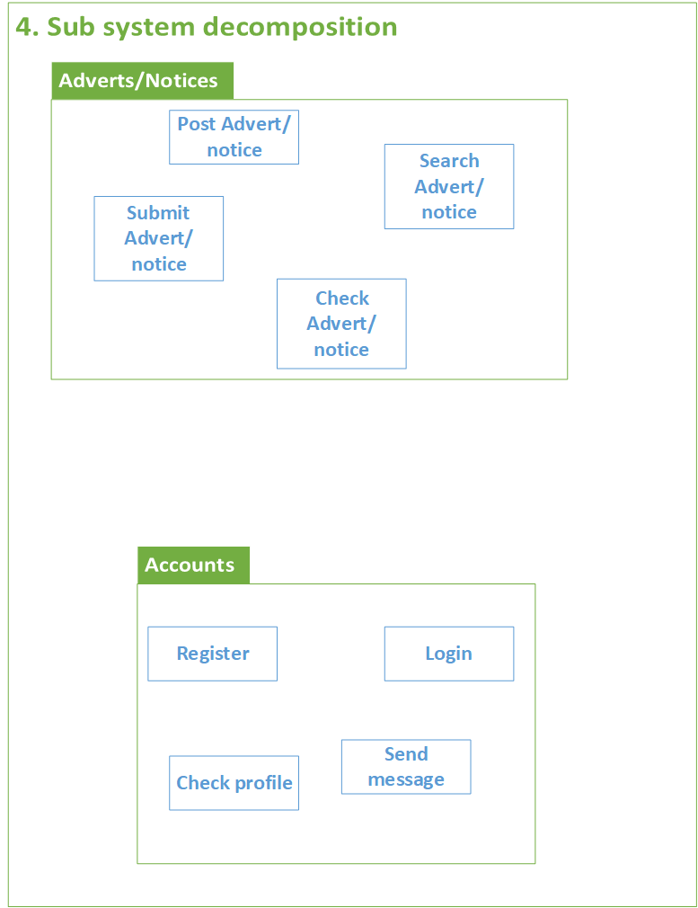

Figure : sub system decomposition

1. **Class diagram**

A class diagram is a static diagram, it’s used to show the existence of the classes and their relationships in the logical view of the system.

It represents the static view of an application. Class diagrams are used for a wide variety of purposes, including both conceptual/domain modeling and detailed design modeling. During analysis we use class diagrams to indicate the common roles and responsibilities of the entities that provide the systems behavior. During design we use class diagrams to capture the structure of the classes that form the systems architecture.

The two essential elements of a class diagram are Classes and their basic relationships.

The major classes of our system are:

* Advert
* Notice
* Advertiser
* Interface Designer
* Project Manager
* Visitor
* Report

Interfaces

* Submit Advert/Notice
* Check Advert/Notice
* Make Payment

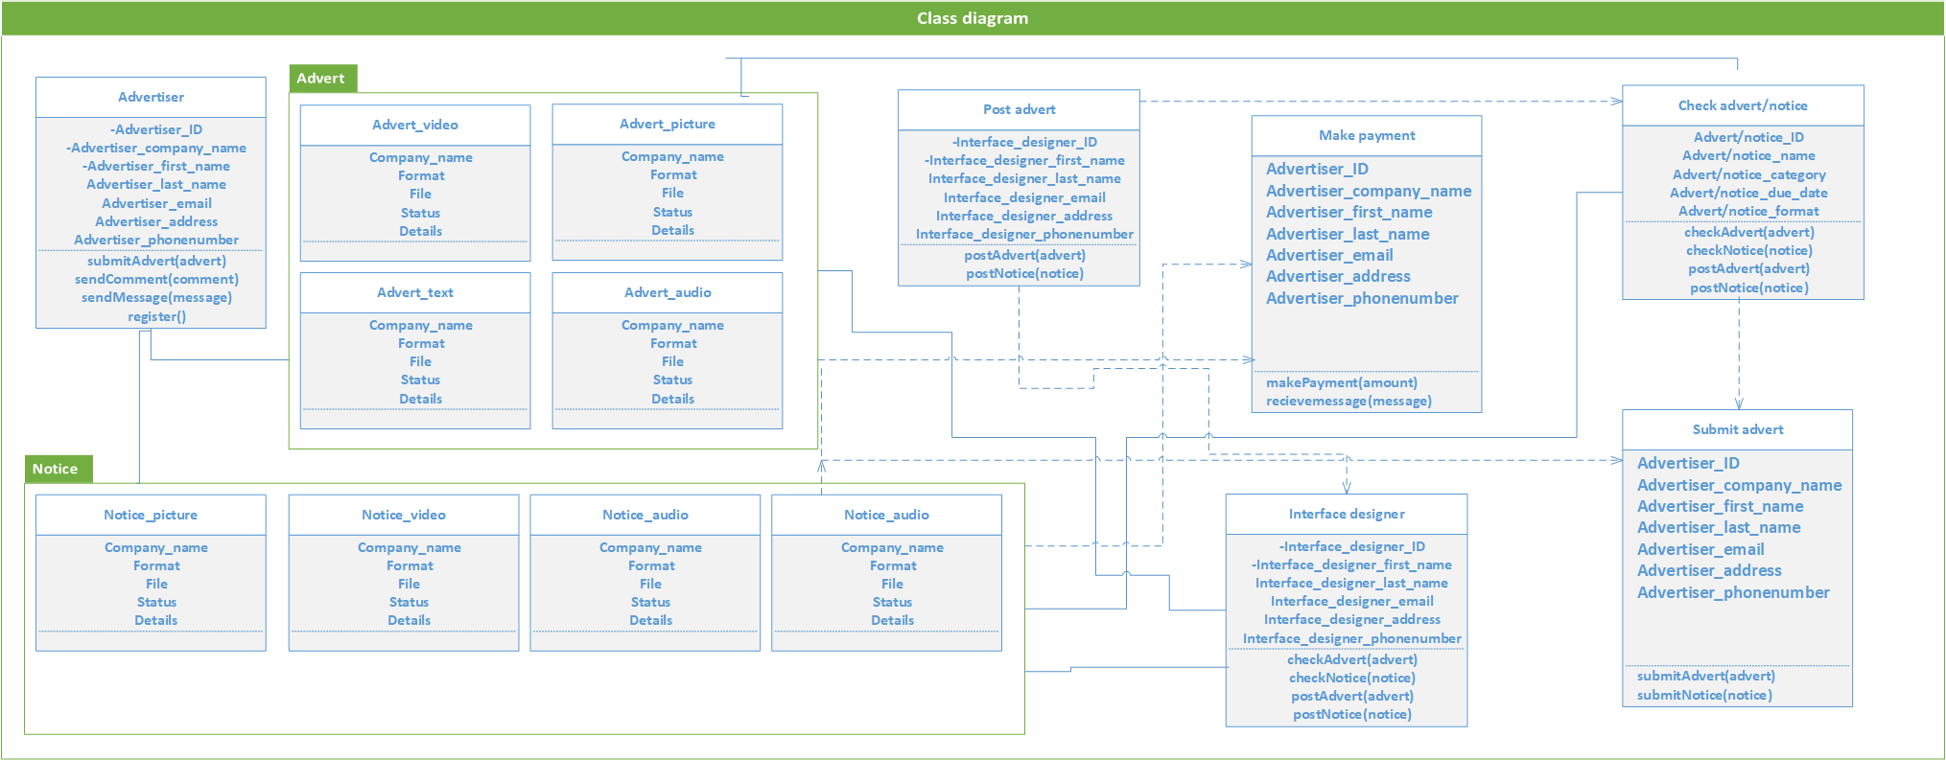

Figure : Class diagram

## **6. Persistent Model**

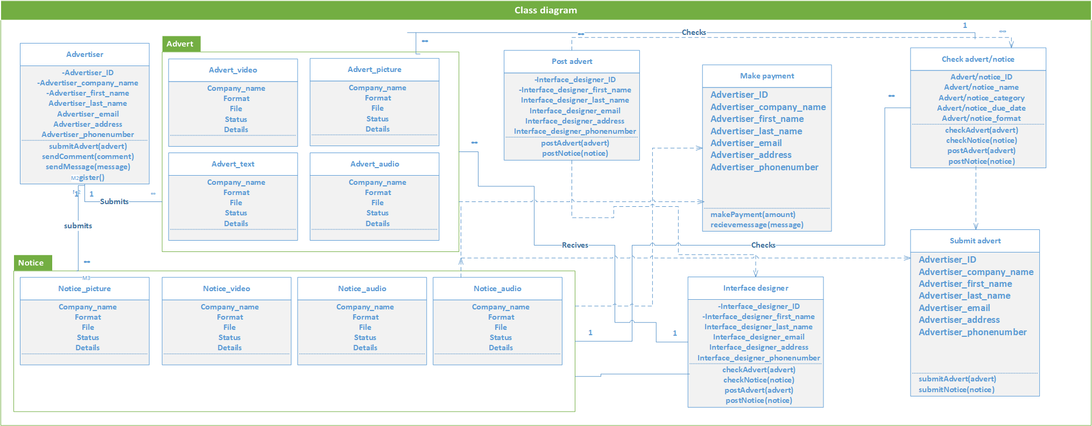

Figure : Persistence model

**6.2** **Normalization**

Database normalization is a technique of organizing the data in the database. Normalization is a systematic approach of decomposing tables to eliminate data redundancy (repetition) and undesirable characteristics like insertion, update and deletion anomalies.

Normalization is used for mainly two purposes,

* Eliminating redundant (useless) data.
* Ensuring data dependencies make sense i.e. data is logically stored.

|  |  |  |  |  |  |  |
| --- | --- | --- | --- | --- | --- | --- |
| **ID** | **Company** | **Format** | **Category** | **File** | **Details** | **Status** |
| 001 | Hope entertainment | Video | Music album | Video.mp4 | Producer  Singer | Post |
| 002 | Flute entertainment | Picture | Music album | Music.mp3 | Producer  Singer | Post |
| 002 | Flute entertainment | Picture | Hotel | Hotel.jpg | Address  Tel | Not post |

Figure : Table to be normalized

#### **1NF (First Normal Formal)**

|  |  |  |  |  |  |  |
| --- | --- | --- | --- | --- | --- | --- |
| **ID** | **Company** | **Format** | **Category** | **File** | **Details** | **Status** |
| 001 | Hope entertainment | Video | Music album | Video.mp4 | Producer | Post |
| 001 | Hope entertainment | Video | Music album | Video.mp4 | Singer | Post |
| 002 | Flute entertainment | Picture | Music album | Music.mp3 | Producer | Post |
| 002 | Flute entertainment | Picture | Music album | Music.mp3 | Singer | Post |
| 002 | Flute entertainment | Picture | Hotel | Hotel.jpg | Address | Not post |
| 002 | Flute entertainment | Picture | Hotel | Hotel.jpg | Tel | Not post |

Figure : 1NF

#### **2NF (Second Normal Form)**

|  |  |  |  |
| --- | --- | --- | --- |
| **ID** | **Company** | **Category** | **Details** |
| 001 | Hope entertainment | Music album | Producer |
| 001 | Hope entertainment | Music album | Singer |
| 002 | Flute entertainment | Music album | Producer |
| 002 | Flute entertainment | Music album | Singer |
| 002 | Flute entertainment | Hotel | Address |
| 002 | Flute entertainment | Hotel | Tel |

Figure : 2NF

|  |  |  |  |
| --- | --- | --- | --- |
| **ID** | **Format** | **File** | **Status** |
| 001 | Video | Video.mp4 | Post |
| 001 | Video | Video.mp4 | Post |
| 002 | Picture | Music.mp3 | Post |
| 002 | Picture | Music.mp3 | Post |
| 002 | Picture | Hotel.mp4 | Not post |
| 002 | Picture | Hotel.mp4 | Not post |

Figure : 2NF

#### **3NF (Third Normal Form)**

|  |  |  |  |
| --- | --- | --- | --- |
| **ID** | **Company** | **Format** | **Category** |
| 001 | Hope entertainment | Video | Music album |
| 002 | Flute entertainment | Picture | Music album |
| 002 | Flute entertainment | Hotel.mp4 | Hotel |

Figure : 3NF

|  |  |  |  |
| --- | --- | --- | --- |
| **Format** | **File** | **Details** | **Status** |
| Video | Video.mp4 | Producer | Post |
| Picture | Music.mp3 | Producer | Post |
| Video | Video.mp4 | Singer | Post |
| Picture | Music.mp3 | Singer | Post |
| Video | Hotel.mp4 | Address | Not post |
| Video | Hotel.mp4 | Tel | Not post |

Figure : 3NF

1. **UI design**

User interface prototype is an iterative analysis technique in which users are actively involved in identifying the user interface of the system. It helps to explore the problem space as well as the solution space of the system at least from the point of view of user (Ambler. 2001).

Here are the major user Interfaces of our system:

**Home page**

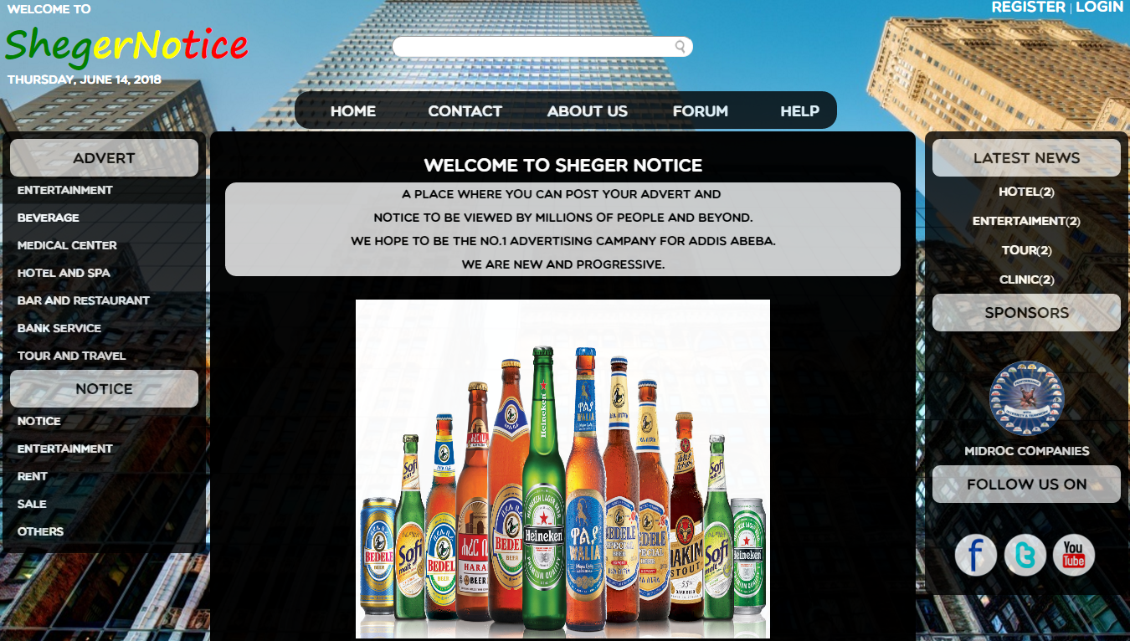

Figure : Home page UI

**Login**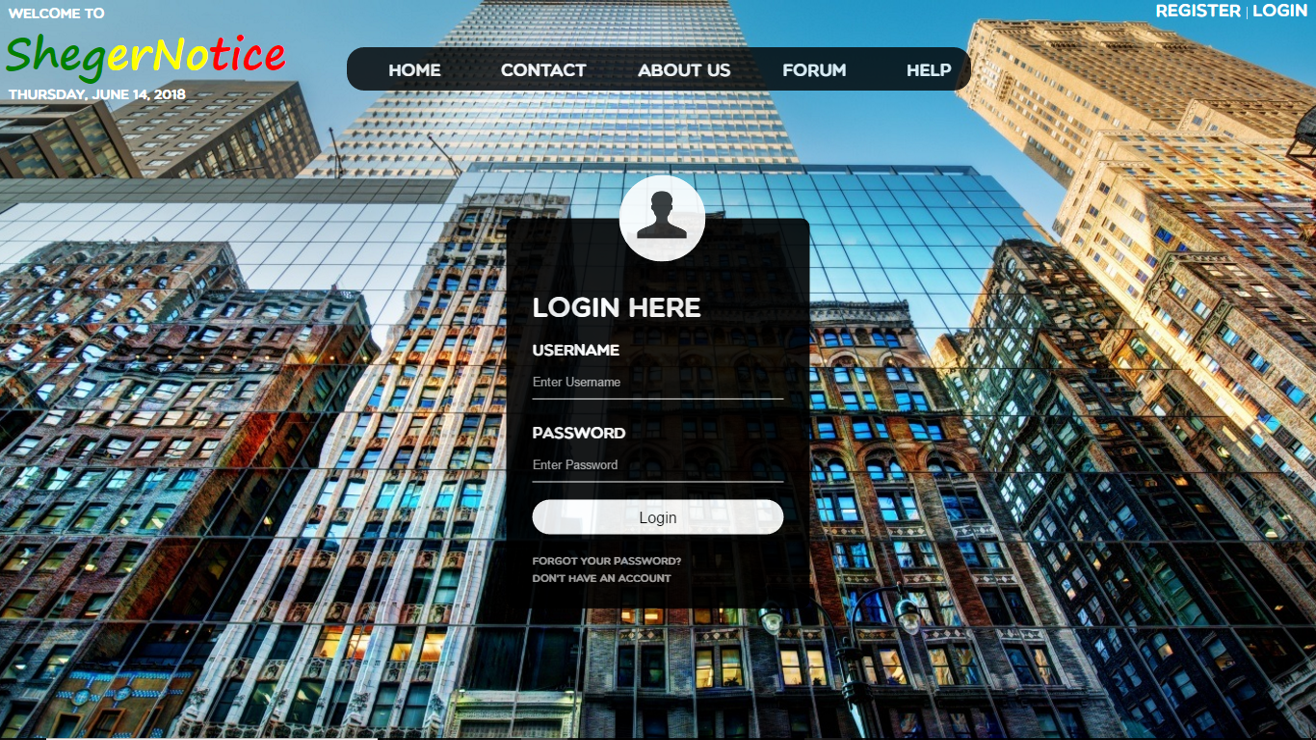

Figure : Login UI

**Register**

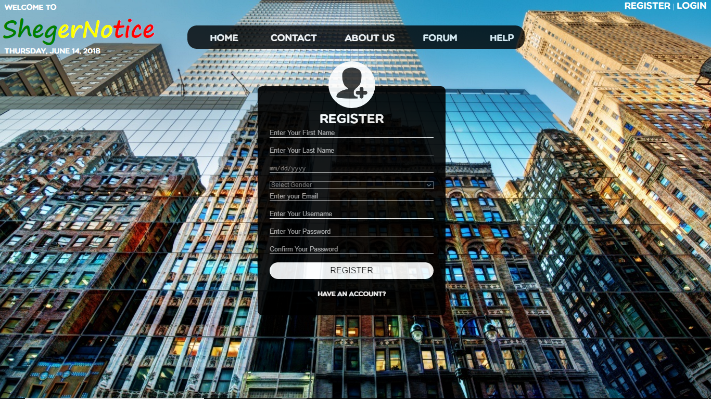

Figure : Register UI

**Contact**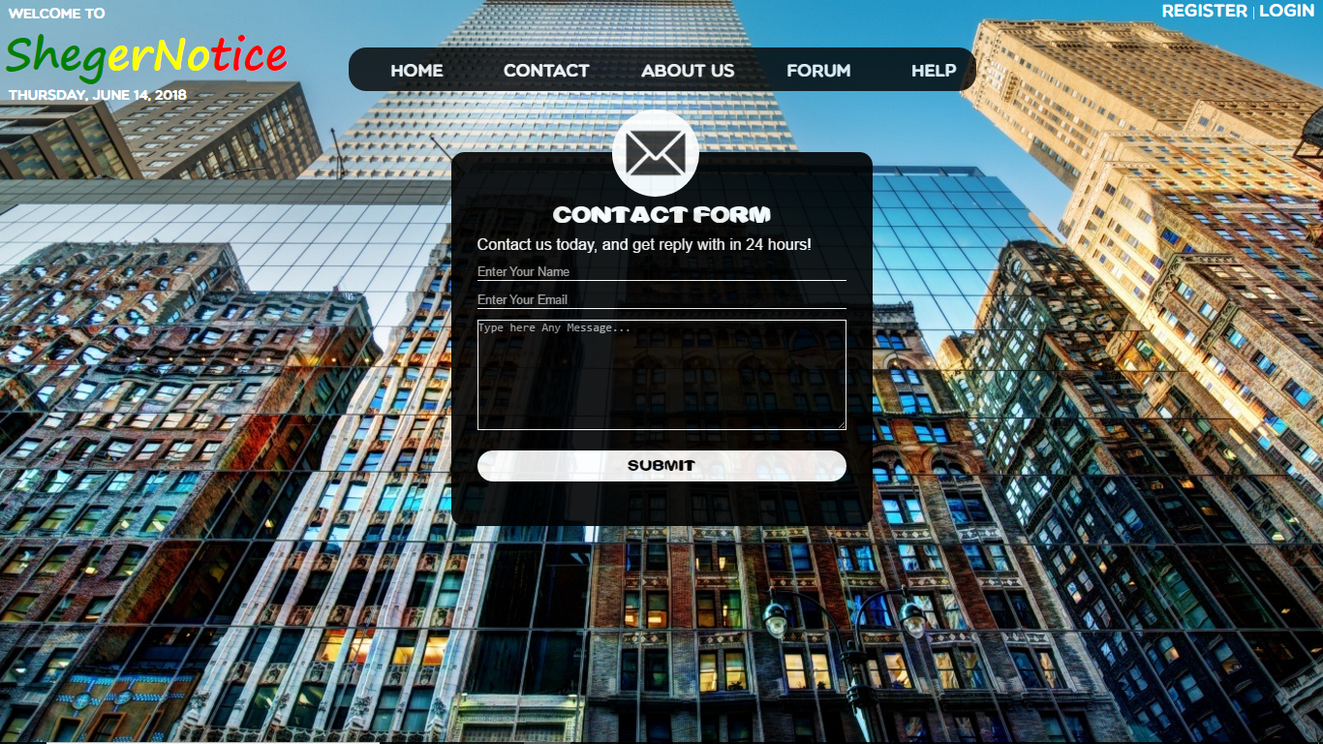

Figure : Contact UI

**About us**

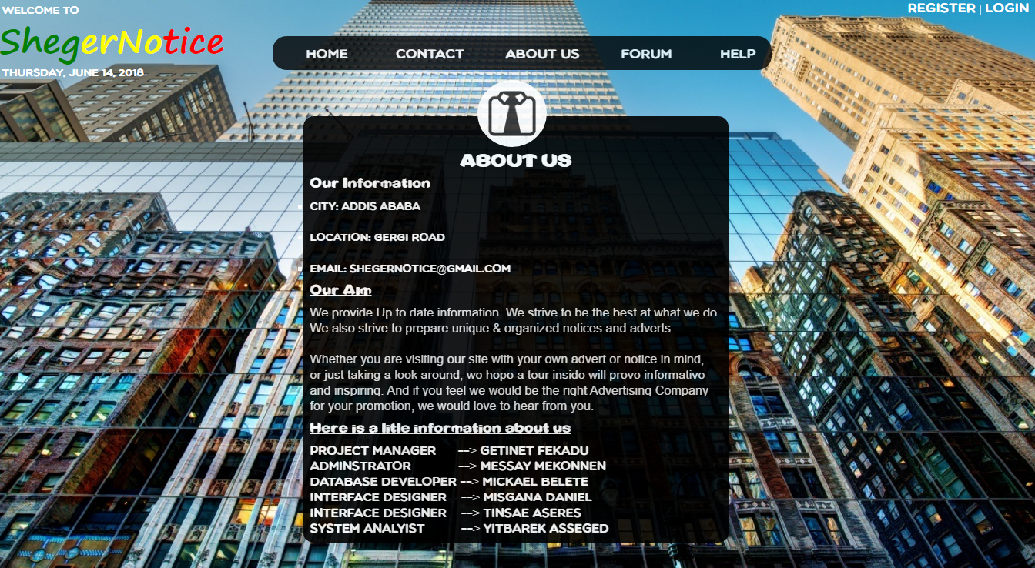

Figure : About us UI

**Advert**

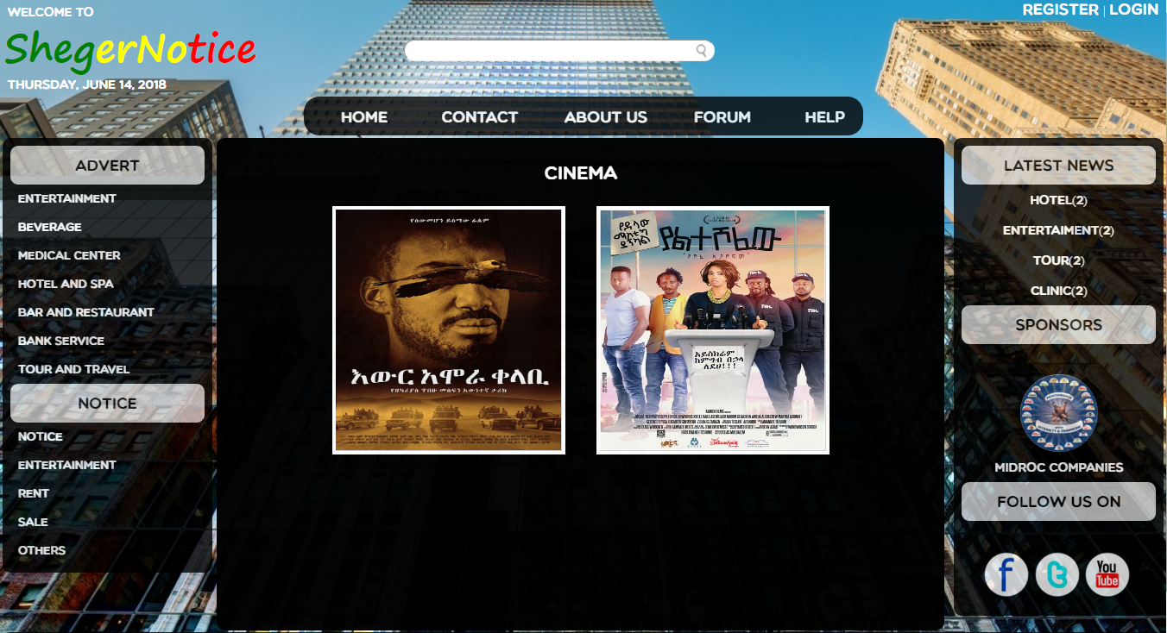

Figure : Advert UI

**Advert**

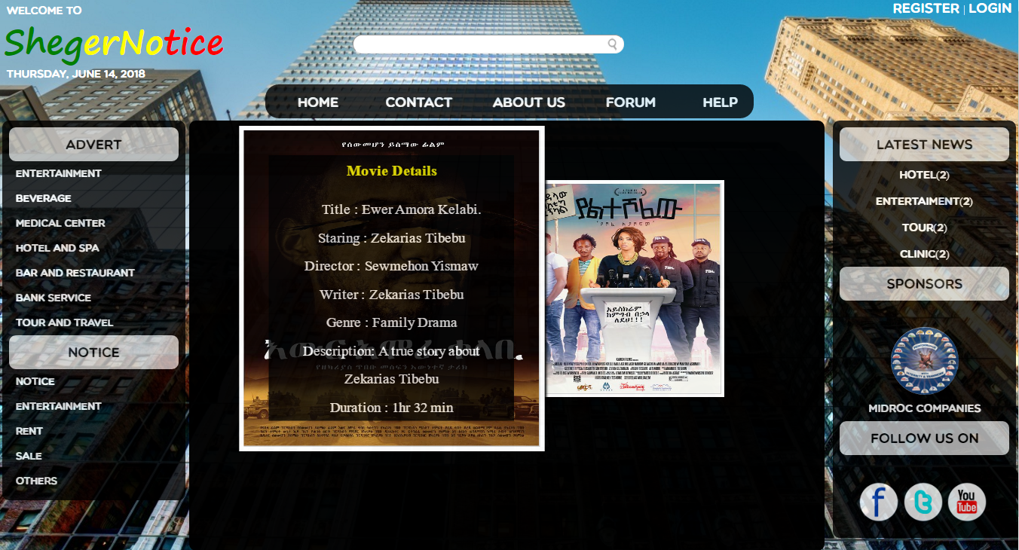

Figure : Advert details UI

**Advert**

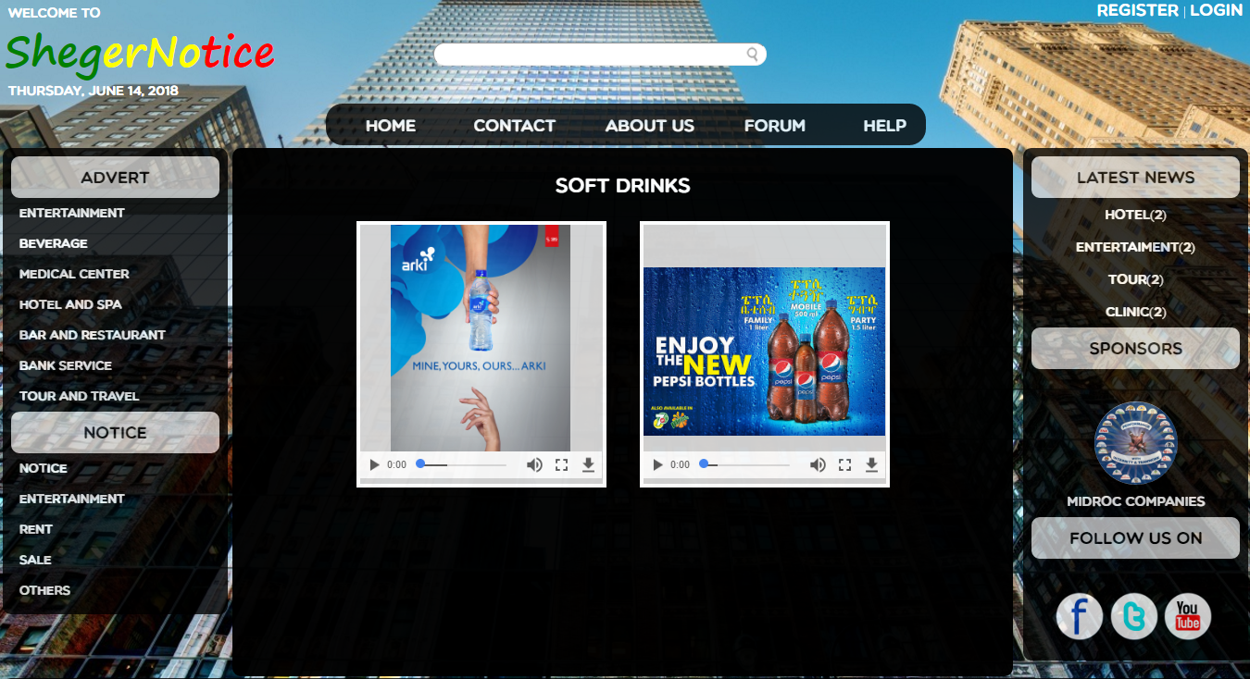

Figure : Video adverts UI

**Advert**

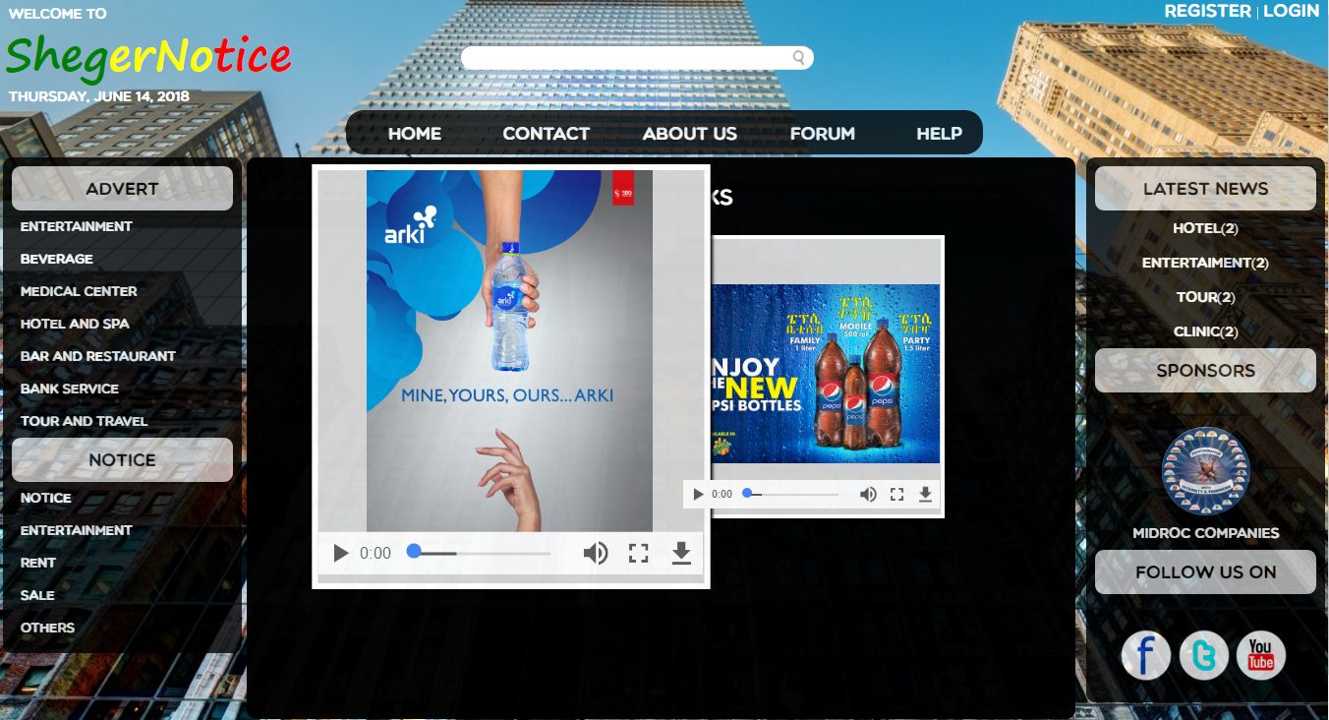

Figure : Advert video play UI

**Notice**

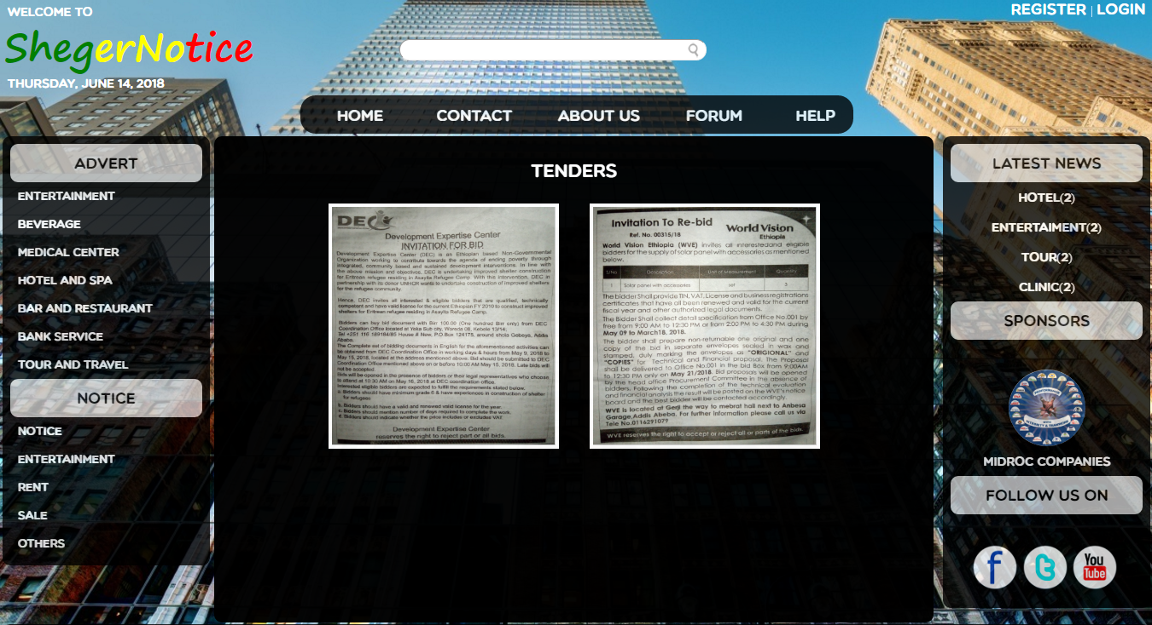

Figure : Notice UI

**Notice**

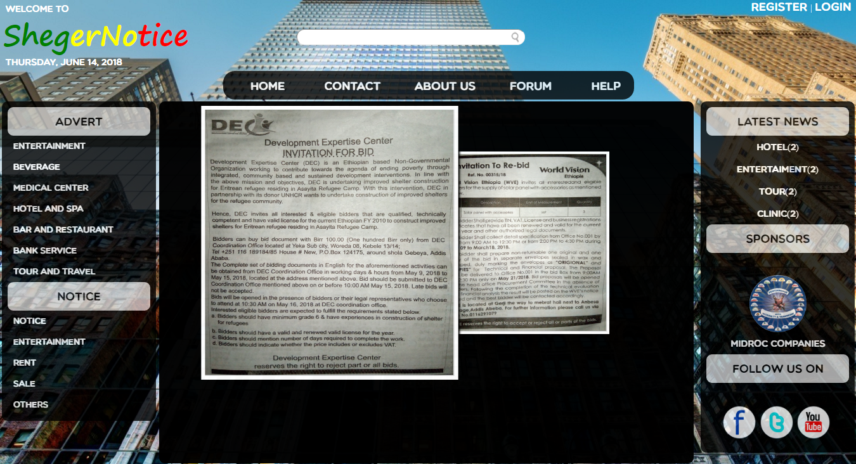

Figure : Notice details

**Submit**

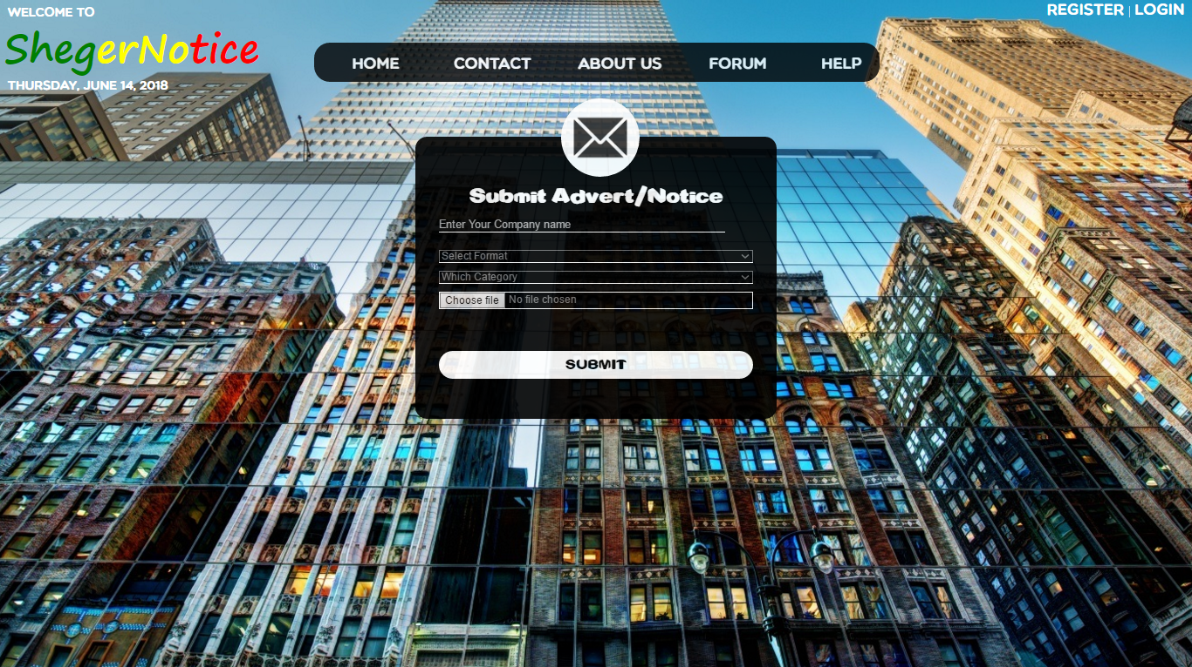

Figure : Submit advert/notice UI

**Admin login**



**Profile of admin**

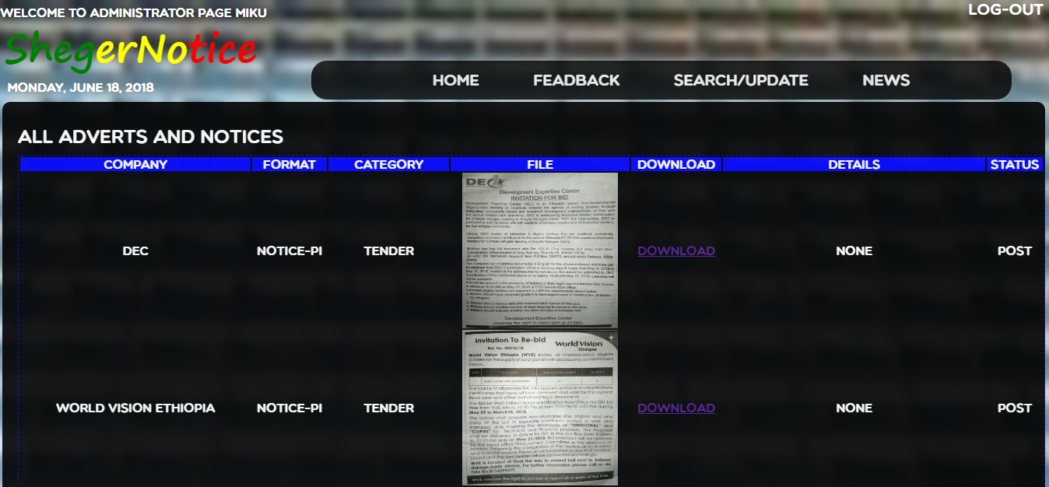

1. **Network Diagram**

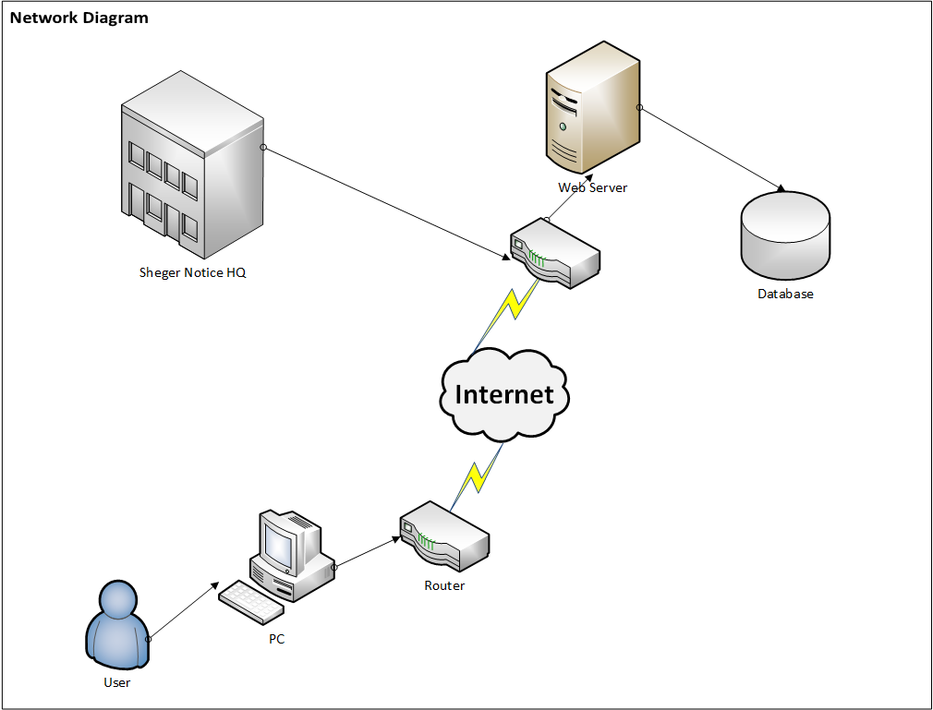

Figure : Network diagram

## **9. Deployment diagram**

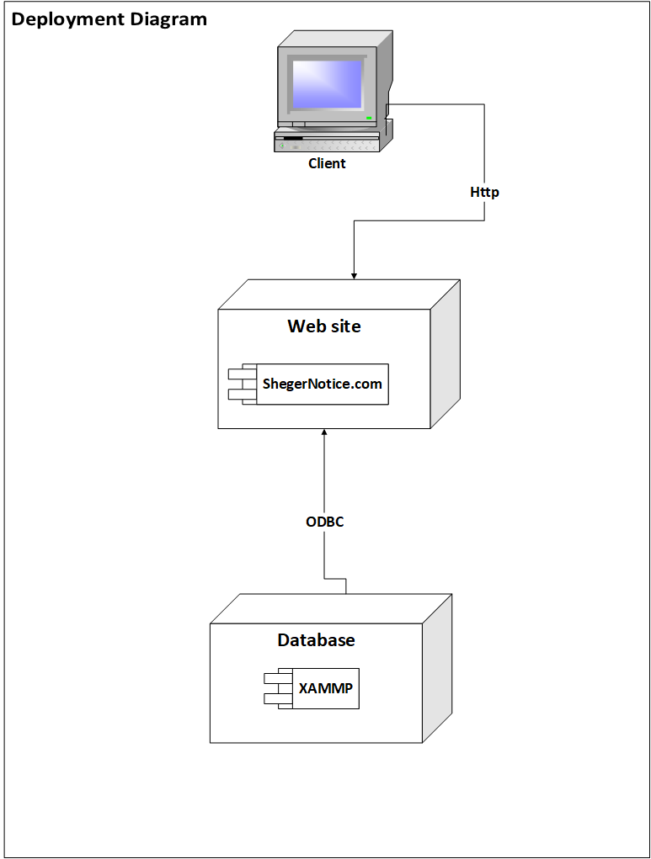

Figure : Deployment diagram

# **CHAPTER FIVE**

# **IMPLEMENTATION**

1. **Introduction**

On implementation, models are translated into source code. If all the above tasks worked properly, the implementation part will be easy. When we first start the project, we bet we make people’s jobs, comforts, safety, entertainment, decisions, and their very lives on advertisement and notice would be different. Until now, all we did, starting from chapter one to four, are for bringing the bet to the ground. For choosing what is best, every decision made starting from what types of programming language, editor, codding style, and server type is to make the implementation better and to present a new experience to the user, the advertiser, and the developers as well. We have implemented our project using website developing tools and different programming languages that are related with website design. We did not use any content management tools (CMT)[3]. Rather every code is from the knowledge is acquired form during the staying of in the university, reference book, and internet-How to’s. We tried to implement every knowledge we have. The website developing tools we have used are:

* Notepad++
* Sublime text

Programming languages used are:

* PHP-
* CSS
* JavaScript

The server used is:

* Apache

1. **Sample code**

**Homepage sample code**

**PHP Code**

<?php

echo "<b>";

echo "&nbsp; Welcome to";

echo "</b>";

?>

<!Doctype html>

<html lang="en">

<head><link rel="icon" href="pic/icon.png" />

<meta charset="utf-8" />

<title>ShegerNotice.com</title>

<link rel="stylesheet" href="css/css.css" type="text/css">

<script type="text/javascript" src="jscript.js"></script>

</head>

<body>

<header>

<a href="index.php"><h1>Sheger Notice</h1></a>

<p><a href="register.php"> Register </a>|

<a href = 'login.php'>Login</a></p><br>

<?php

$Today=date('y:m:d');

$new=date('l, F d, Y',strtotime($Today));

echo "<br> &nbsp; $new";

?>

<form name = "searchform" id = "formsearch">

<input type = "text" id = "searchtextbox">

<button id = "submit" type = "submit"><img src ="pic/search.png" alt="search logo" width=19></button>

</form>

</header>

<nav>

<ul>

<li><a href="index.php"> HOME </a></li>

<li><a href="contact.php"> CONTACT </a></li>

<li><a href ="aboutus.php"> ABOUT US </a></li>

<li><a href="help.php"> HELP </a></li>

</ul>

</nav>

<aside>

<h3>Advert</h3>

<ul>

<li><a href="">Entertainment</a>

<ul>

<li><a href="cinema.php">Cinema</a></li>

<li><a href="music_festival.php">Music Festival</a></li>

<li><a href="concerts.php">Concert</a></li>

<li><a href="music_album.php">Music Album</a></li>

<li><a href="books_magazines.php">Books and Magazines</a></li>

<li><a href="sport_events.php">Sport Events</a></li>

</li>

</ul>

<li><a href="#">Beverage</a>

<ul>

<li><a href="soft_drinks.php">Soft Drinks</a></li>

<li><a href="alcohol.php">Alcohol</a></li>

</li>

</ul>

<li><a href="Medicalcenter.php">Medical Center</a></li>

<li><a href="#">Hotel and Spa</a>

<ul>

<li><a href="starhotel.php">Star Hotel</a></li>

<li><a href="hotelspa.php">Hotel and Spa</a></li>

<li><a href="hotel.php">Hotel</a></li>

<li><a href="spa.php">Spa</a></li>

</li>

</ul>

<li><a href="#">Bar and Restaurant</a>

<ul>

<li><a href="bar.php">Bar</a></li>

<li><a href="restaurant.php">Restaurant</a></li>

</li>

</ul>

<li><a href="bank.php">Bank Service</a></li>

<li><a href="#">Mall</a>

<ul>

<li><a href="mallrent.php">Rent</a></li>

<li><a href="mallbuy.php">Buy</a></li>

</li>

</ul>

<li><a href="">Tour and Travel</a></li>

</ul>

<h3>Notice</h3>

<ul>

<li><a href="#"> Notice </a>

<ul>

<li><a href="tender.php">Tender</a></li>

<li><a href="jobs.php">Jobs</a></li>

<li><a href="education.php">Educations</a></li>

<li><a href="events.php">Events</a></li>

</ul>

</li>

<li><a href="#">Entertainment</a>

<ul>

<li><a href="cancelled.php">Cancelled </a></li>

<li><a href="venue_change.php">Venue changed</a></li>

<li><a href="price_cahnge.php">Entrance price changed</a></li>

<li><a href="schedule_change.php">Schedule changed</a></li>

</ul>

</li>

<li><a href ="#">Court</a>

<ul>

<li><a href="court_date.php">Official court date</a></li>

<li><a href="court_forclusures.php">Court foreclosures</a></li>

<li><a href="court_changed_date.php">Court changed date </a></li>

<li><a href="court_notice_board.php">Court notice board</a></li>

</ul>

</li>

<li><a href="#">Rent</a>

<ul>

<li><a href="houses.php">House Rent Notices</a></li>

<li><a href="shops.php">Shop Rent Notices</a></li>

<li><a href="cars.php">Car Rent Notices</a></li>

<li><a href="equipments.php">Equipment Rent Notices</a></li>

</ul>

</li>

<li><a href ="#">Sale</a>

<ul>

<li><a href="sale_notice_houses.php">House Sale Notices</a></li>

<li><a href="sale_notice_car.php">Car Sale Notices</a></li>

<li><a href="sale_notice_equipments.php">Equipments Sale Notices</a></li>

<li><a href="sale_notice_cosmos.php">Cosmetics Sale Notices</a></li>

</ul>

</li>

<li><a href ="bill.php">Bills</a></li>

<li><a href ="Charity.php">Others</a></li>

</ul>

</aside>

<section>

<h2>Welcome To Sheger Notice</h2>

<p>

A place where you can post your advert and <br>

notice to be viewed by millions of people and beyond.<br>

We hope to be the No.1 Advertising campany for Addis Abeba.<br>

We are new and progressive.

</p>

<br>

<center>

<img id = "imagesrc" src = "cinima Pics/1.jpg">

<button onclick="changepcituretoleft()" id ="left" >

<img src= "pic/arrow-right_active_2.png" class=l ></button>

<button onclick="changepcituretoright()" id ="right">

<img src = "pic/arrow-right_active.png" class=l ></button></center>

<br>

</section>

<aside class="right">

<h3>Latest News</h3>

<a href="">Hotel(2)</a><br>

<a href="">Entertaiment(1)</a><br>

<a href="">Tour(1)</a><br>

<a href="">Clinic(3)</a>

<h3>Sponsors</h3>

<br><a href="http://www.cocacola.com"><img id="big" src="pics/1 (9).jpg" ></a><br>

<a href="http://www.midroc.com"><label>Midroc Companies</label></a><br>

<h3>Follow us on</h3>

<br>

<a href="http://www.fb.com"><img id="small" src="pic/f.png" /></a>

<a href="http://www.twitter.com"><img id="small" src="pic/t.png"/></a>

<a href ="http://www.youtube.com"><img id="small" src="pic/y.png"/></a><br>

</aside>

<footer>

<p>Copyright &copy; 2018 <a href="index.php">ShegerNotice.com</a></p>

<center><i>(In Compliance with Advertisement Proclamation No.759/2012)</i></center>

</footer>

</body>

</html>

**CSS Code**

*{ margin:0px;

padding:0px;}

body{ background-image: url(../pic/body.jpg);

background-size:cover;

background-position:center;

background-repeat:no-repeat;

font-family: Multicolore;

line-height:2.0;

color:white;}

header a { color:white;

text-decoration:none;

font-size:24px;}

header a:link, header a:visited{ color: white; }

header p{ text-align:right;

margin:-120px 10px 0px 0px; }

header p a{ font-size:20px; }

header p a:link, header a:visited{ color: white; }

header p a:hover{color:black;}

header a h1{ margin-top:-20px;

text-indent:5px;

font-family:Segoe Print;

font-size:50px; }

button#submit{ position : absolute;

top : 6pt;

left : 380pt;

height : 15pt;

border-radius :10pt;

background-color : white;

border : 0;}

#searchtextbox{ width : 300pt;

height : 21pt;

margin : 3pt 2pt 0pt 100pt;

border-radius :10pt;}

#formsearch{ position : absolute;

top : 35pt;

left : 290pt;}

nav{ background:black;

border-radius :15pt;

text-indent: -20px;

color:white;

opacity:0.8;

text-align: center;

width:680px;

padding:5px;

margin: 0px auto 0 auto;}

nav li{ display:inline-block;

padding-left: 65px; }

nav li a{ text-decoration : none;

font-size:20px;}

nav li a:link,nav li a:visited{ color: white; }

nav li a:hover{ color: black;

background:white;}

aside, section, footer{ margin:3px;}

aside, aside.right{ padding:10px;

line-height:2.5;

background: black;

opacity:0.8;

color:white;

border-radius :10px;

width:220px;

height:auto;

float:left;}

aside ul, aside ul li ul{ text-indent:10px;

list-style:none; }

aside ul li{ font-size: 15px;}

aside ul li ul li{display:none; font-size: 12px;}

aside ul li a, aside.right a{ text-decoration:none;

color:white;

}

aside ul li a:hover,aside.right a:hover{ color:darkgrey;}

aside ul li ul li a{ color:turquoise;}

aside ul li ul li:hover a{ color:white;

background:none;}

aside ul li:hover ul li{ display:block;}

aside h3 { font-size: 20px;

text-align:center;

border-radius :10px ;

opacity:0.8;

background-color: white;

color:black;}

aside.right{ float:right; text-align:center;}

aside.right a img#small{width:65px; height:65px;}

aside.right a img#big{width:150px; height:120px;}

section { float:left;

padding:10px;

border-radius :10px;

text-align:center;

opacity:0.980;

background-color: black;

color:white;

font-size:16pt;

width:710px;

height:auto;}

section p { text-indent:20px;

border-radius :10px ;

opacity:0.8;

background-color: white;

color:black;}

section p h2{font-size:20pt;}

section p.photo{ height:200pt;

width:170pt;

text-align: center;}

section button { position: absolute;

top:700px;

border :0;

background: none;}

section img { display: inline-block;

padding:10px;

width:280px;

height:310px;}

section img#a{float:middle;

width:700px;

height:800px; }

section button#left{ left:340px; }

section button#right{ left:830px;}

section img.l { width:40px;

height:40px;}

section img#imagesrc{ width:400px;

height:450px;}

section img#all{ width:400px;

height:500px;}

section span#y{font-family:sans-serif;

font-size:15pt;}

section video {float:left;

width:450px;

height:400px;}

footer{ clear:both;

opacity: 0.8;

padding:25px;

border-radius :10px;

background:black; }

footer p{ font-size:20px;

font-family:Verdana;

color:white;

text-align:center;}

footer i { text-align:center;

font-size:12pt;

font-family:Arial;

}

footer p a { text-decoration : none;}

footer p a:link,footer p a:visited{ color: white; }

footer p a:hover{color:darkgrey;}

**JavaScript**

var imagefiles = new Array("Concerts/1.jpg","cinima Pics/2.jpg","Concerts/2.jpg");

var i = 4;

function changepcituretoright() {

setTimeout(changepcituretoright,9000);

if(i >= imagefiles.length-1)

{

i = 0;

}

else

{

document.getElementById("left").disabled = false;

i = i + 1;

}

document.getElementById('imagesrc').src = imagefiles[i];

}

function changepcituretoleft()

{

if(i >= imagefiles.length-1)

{

i = 0;

}

else

{

document.getElementById("left").disabled = false;

i = i + 1;

}

document.getElementById('imagesrc').src = imagefiles[i];

}

# **CHAPTER SIX**

# **CONCLUSION AND RECCOMENDATION**

1. **Conclusions**

The finding of the project has been presented and discussed as follow. The concussion tries to see the way an advertisement and notice presented (platform), the contents of the advertisement and notice and on the ethics of advertisement and notice. The group member has drawn the following conclusion.

1. When we start the project we were focused on the cleanness of the city, rather we find that the advertisement/notice ‘industry’ is unregulated and unorganized. The way an advertisement and notice are disseminated through the city reached to a dangerous level. You can distribute any advertisement through the city on broad day light or in disguise without any consequence.
2. There are a couple of advertisements/ notices boards around the city. We noticed that it is difficult to find a particular subject, if you find it you don’t know a particular subject matter due date passed or not, it has limited information, there is no categories, lack adequate lighting, unaccusable to handicap person, etc.

1. Why enact laws if we are not implementing it? There is advertisement law that is not fully implemented. The lack of ethics on both advertiser and advertisement agent emanates from this. Unimplemented laws and regulations is means of the problem by providing gap between the law and practice. If the city administrator implementing laws partially it is responsible with what happens to the other half of unimplemented laws. Directly speaking, the city administration lacks the capacity.
2. Addis Ababa considered to be the capital city of Africa, so optics is everything. Nevertheless, the city is not matching its name (new flower). If every walls and polls plastered with papers, it tells there is something unnatural optically. Additionally, behind that, it shows lack of commitment to regulate the advertisement industry.
3. None vetted advertisement and notices that are unlawful, immoral, and culturally wrong contents are rampant. The reason is that first, advertisers may want immediate high volume of sales rather than long run favorable image. Second, this may be due to lack of creative message design and presentations. If you sell a weight loss substance, you should have a permission to it. However, nowadays if you have a printer and know how to write on a computer or paid, you can poster it just by paying one Birr per sheet. Your advertisement/notice might be unlawful, immoral, wrong content culturally.
4. Even though, the industry has relatively professional employees in Marketing Development and Promotion section, still the marketing concept and practice are at infant stage. There is no strong regulation code of conduct at the government level. The practice, which is in working by the industry have not given attention to the problem of advertisement/notice ethics. The procedures followed by conducting advertisement/notice focused on revenue generation. There are unethical advertisements/notice such as exaggerating the quality and services of products. As long as you pay, you are entitled to your advertisement/notice.
5. As the content analysis of advertisement/notice disseminated in Addis shows, advertisements/notices have problem of imitation from the foreign language to direct local language. This shows that lack of consideration for the culture, language and norms of the society.
6. Lack of simplicity in advertising is at the very sentiment of the industry’s misconception. We can see some of the advertisements behavior lack of simplicity. Like exaggeration, keywords does not directly relate to the advertisement content, lack clarity in communicating the features of the product, the service/distribution location and other customer service related matters, contain information which is totally irrelevant to customer’s product knowledge, messages have no logical link with the product or products being communicated, and false claims.
7. **Recommendations**
8. The root problem of the advertising/notice industry is unregulated and unorganized advertisements and notices dissemination. Using digital means of dissemination of advertisement and notice is the best way because it can be managed easily, as we proposed in our system. Alternatively, making accountable everyone who disseminates advertisement and notice based on the contents of their advertisement and notice if possible.
9. Our system is the best way to find a particular subject, you know whether the due date is passed or not, there are multiple categories, you ca adjust your own device lighting, and finally it is accessible to handicap person because it is displayed on computer screen.
10. If the city legislators legislate laws, the city executive branch has to enforce it. Otherwise, laws may be repealed by disuse. There must be an awareness campaign to what, and how to advertise and tell a notice to the public. As the citizen has right and responsibilities so as the administration has the responsibility to follow up how it is being executed. But, if our system implemented we can inspect every content weather it is immoral, unlawful, or against public moral.
11. The factor that the city is not clean is partly because the way the advertisement and notice are disseminated. If advertisers and notice tellers use our system there will be no residual that is outputted to the environment that affect the cleanness of the city. Or There should be a standard display option or use our system and the commitment to keep our city clean.
12. Advertisements and notices that are unlawful, immoral, and culturally wrong contents is crime. If such advertisements and notices are found the advertiser/ notice teller and the advertisement agent must be liable to the extent of their damage. Being an agent must entail greater responsibility than selling high volume. If our system implemented it possess through many processes so that any unlawful, immoral, and culturally wrong contents doesn’t appear on the screen.
13. We strongly recommend that advertisers/notice tellers to respect the culture and norms of the society. They should be frontier to break the misconception that whenever a white man appears on the adverts it is better quality than the rest of the product. If possible, local language, is the best advertisement language, ordinary people on ordinary situation must be presented than a superficial one. Otherwise, use simplicity.
14. Some advertisements are so complex that even the agent could not tell what the content of the advert is; rather disseminating simple advertisement and notice is best practice. Avoid exaggeration and misleading contents. Putting direct information about the product and service must be a best practice.

# **Bibliography**

Ambler, S. W., 2001. *The object primer- The Application Developer's Guide to object Orientation & the UML,* Cambridge: Cambridge University Press.

Anon., 2012. *Advertisment proclamation No. 759/2012.* Addis Ababa: FDRE.

Anon., 2016. *W3Schools.com.* [Online]   
Available at: http://www.W3School.com  
[Accessed 04 April 2018].

Anon., 2017. *youtube.com.* [Online]   
Available at: http://www.Youtube.com  
[Accessed 05 November 2018].

Bulger, J. \. a. B., 2011. *MySql/Database Application ,* CA: M&T Books.

Gilorien, 2012. *Cascading Style Sheets,JavaScript Style Sheets,& JavaScripted Layers plus advancedJavaScript 1.2 & 1.3,* s.l.: Prentice Hall PTR.

Grady Booch &Robert A. Maksimchuk&Michael W. Engle&Bobbi J. Young, P. C. A. H., 2007. *Object-Oriented Analysis and Design with Applications,* Bosten: Addison wesely.

Haverbeke, M., 2014. *Eloquent JavaScript A Modern Introduction to Programming,* s.l.: MIT.

Nixon, R., 2015. *Learning_PHP__MySQL___JavaScript_With_jQuery__CSS___HTML5__4th_Edition,* CA: O’Reilly Media, Inc..

Powell, T. A., 2010. *REFERENCE & CSS:The commplete reference,* NY: mcGrow-Hill.

project, u. U. s. f., n.d. *web based education system.* Addis Ababa: unity University.

R., R. S. &. B., 2015. *Software Engineering A Practitioner’s Approach,* NY: mcGrow-Hill Education.

Students, U. U. F. p., 2015. *Real State managment System for Gesher Costruction PLC.* Addis Ababa: Unity University.

Tegarden, A. D. &. B. H. &. W. &. D., 2005. *System Analysis and Design with UML Version 2.0,* NJ: John Wiley & Sons.

W.Ambler, S., 2004. *The_Object_Primer_-_Agile_Model-Driven_Development_with_UML,* Cambridge: Cambridge University press.

1. e-board: referred to an electronic board
2. An advertiser may be a business that is legally formed, or a natural person.
3. Content management tools (CMTs) are software’s that are used to develop web site without any or little coding knowledge.